**A system to manage the occupancy of a housing community**

**UIT2211 – SOFTWARE DEVELOPMENT PROJECT – I**

**A PROJECT REPORT**

***Submitted by***

**S. Selcia – 3122215002098**

**Shashwat Shivam – 3122215002099**

**V. Shasvat Vijay – 3122215002100**

**Sherwin Satya. A – 3122215002101**

**S. Shrikar – 3122215002102**

**SSN COLLEGE OF ENGINEERING,**

**KALAVAKKAM**

**AUGUST 2022**

**Sri Sivasubramaniya Nadar College of Engineering**

**(An Autonomous Institution, Affiliated to Anna University)**

**BONAFIDE CERTIFICATE**

Certified that this project titled “A system to manage the occupancy of a housing community” is the bonafide work of “S. Selcia – 3122215002098, Shashwat Shivam – 3122215002099, V. Shasvat Vijay – 3122215002100, Sherwin Satya. A – 3122215002101, S. Shrikar – 3122215002102”, and is submitted for project viva-voce examination held on 26.08.2022.

**Signature of examiner(s)**

**ACKNOWLEDGEMENT**

We would like to express our sincere gratitude to Dr. Aravindan Chandrabose and Dr. S. Karthika who gave us the golden opportunity to work on this project. A special thanks to our teachers Dr. K. R. Uthayan and Dr. J. Betina Antony for their constant guidance and support throughout the project.

Secondly, we would also like to thank our parents, relatives and friends who constantly supported and motivated us to complete the project within the limited time frame.

We are highly obliged to all those who guided and helped us out in completing this project successfully.

**PROJECT REPORT**

1. **Abstract of the project**

We are stuck with technology when what we really want is just stuff that works. With the current paradigm shift in technological field, there is an urgent need to embrace and appreciate the power of technology. Housing sector remains vigilant to face the challenges of change by employing a new strategy that facilitates easy management of rental houses. Hence there is need to develop a rental house management system that can simplify work for the rental managers so that all their work can be efficient and effective.

Our aim is to create a simple GUI that can allow the user to book a flat and enables the admin to manage the occupancy of the housing community easily and effectively. To develop this system, we have used Tkinter module in Python as our frontend and in the backend, we have used JSON files to store data.

This system has three login modules where-in each module has a different functionality.

1. ADMINISTRATOR MODULE –

In this login portal, only the system administrator will be able to login and see the details of the occupants.

1. OCCUPANT MODULE –

Here only the occupants who’ve already bought the house and are residing in it will be able to login through this portal. The occupant must pay the monthly maintenance fee every month.

1. NEW USER MODULE –

This module will allow the user to create an account if he doesn’t have one and allows him to login if he’s an existing user.

This system will help the tenants to find home that they’ll love at ease. This online rental management system will reduce paper work and make things simpler.

1. **Introduction**

**Motivation**

The software is needed to provide people with a better and an easier way of searching for a roof over their head at a reasonable price. Buying, Selling, Renting, or moving into a house can be a trial by fire, especially in India where we often take the hassles involved in the process as an integral part of the home purchase process. Our new idea for GroupOD Housing Community questions that behavior and motivates them to switch to a hassle-free experience.

**Problem statement**

A newly established housing community association wants to develop a system to manage the occupancy of their community. The system should be able to generate a block-wise list of occupied and unoccupied houses. The details of the occupants should also be displayed based on their flat numbers. The system should display the availability of houses based on the BHKs for new clients and any new occupancy must be updated in the system. The system should also track the payment of monthly maintenance charges for all the occupied flats.

**Objectives**

The advancement in Information Technology and internet penetration has greatly enhanced various business processes and communication between companies and their customers. This House Rental System is developed to provide the following services:

* To develop a system to generate a block-wise list of occupied and unoccupied houses.
* The administrator must be able to view the block-wise list of occupied and unoccupied houses, details of the occupants with their block and flat numbers & maintenance fee status.
* The occupants must be able to pay their monthly maintenance fee.
* The new user must be able to create a new account to login.
* The new user must also be able to view the details of the apartments i.e., occupancy, price and the type of BHK.

**Deliverables**

The main deliverables of this project will be the complete software system and the software engineering document that includes:

* The admin to login through the login portal, view the details of the occupants along with their flat and block numbers and track the occupant’s monthly maintenance fee.
* After successful login, the occupant must be able to pay the monthly maintenance fee either pay through UPI or Net banking.
* The new user can sign-up if he doesn’t have an account based on certain criteria for setting the username and password. After successful creation of account, the occupant can either visit the new user page and view the houses available or can book a house by viewing block number, flat number, BHK type, occupancy and price.

1. **Requirement Engineering**

**Client details**

|  |  |
| --- | --- |
| NAME | MARY ANTONETTE |
| DATE OF BIRTH | 04.11.1982 |
| PHONE NUMBER | 8778377419 |
| ALTERNATE PHONE NUMBER | 9865979966 |
| CONTRACT ACCEPTANCE DATE | 13.06.2022 |
| EMAIL | groupod4@gmail.com |
| ADDRESS | 158 E 126th St, New York, NY 10035, United States |
| REFERRED BY | JEBICIA |

**Functional modules in our project**

1. The Admin Module – To manage the occupancy of the whole system i.e., the occupancy and to track the payment of monthly maintenance fee.
2. The Occupant Module – To pay the monthly maintenance fee and to vacate the residing house if they want to.
3. The New User Module – To create a new account to login and see the details of the flats based on type of BHK and price. To book their desired flat.

**SPRINT – 1**

|  |  |  |  |  |  |  |
| --- | --- | --- | --- | --- | --- | --- |
| **Sprint #** | **Epic** | **User Story #** | **Requirement / User Story** | **Essential or Desirable** | **Description of the Requirement** | **Remarks** |
| 01 | Admin module | 1 | The admin should be able to view who all have paid the monthly maintenance fees | Essential | A column in the displayed window will contain whether monthly maintenance fees has been paid by the respective house | A window is displayed regarding payment status of all the occupants |
| 02 | Admin module | 2 | The admin should be able to view the details of all the members of the housing community | Essential | A window will be displayed showing the block no., house no., name, contact number and aadhaar number. | A window is displayed for the admin to view occupant details |
| 03 | Admin module | 3 | The admin should be able to send an intimation to all flat owners if they have not paid that month’s maintenance fee | Desirable | An automated message generation system can be built. | A window is popped up showing a message to pay the fee |
| 04 | Admin module | 4 | As an admin, he must be able to see the occupancy status | Essential | A table displayed with a column showing Occupied if the details of the occupant is found, else not occupied | A table is displayed showing the details of customers |
| 05 | Admin module | 5 | As an admin, the admin should be able to login only through the admin login | Essential | The username & password should be separate for admin. | Admin has a separate login portal |
| 06 | Admin module | 6 | As an admin he must be able to remove an occupant if he / she vacates the flat | Essential | The admin must enter the block and flat number which is to be vacated | The flat gets vacated and is ready for a new user to book the flat |

**SPRINT – 2**

|  |  |  |  |  |  |  |
| --- | --- | --- | --- | --- | --- | --- |
| **Sprint #** | **Epic** | **User Story #** | **Requirement / User Story** | **Essential or Desirable** | **Description of the Requirement** | **Remarks** |
| 01 | Occupant module | 1 | As an occupant, the occupant should be able to login only through the occupant login | Essential | The username & password should be present in the separate login details | Occupant has a separate login portal |
| 02 | Occupant module | 2 | The occupant should be able to view if monthly maintenance fees has been paid | Essential | A message box will be displayed showing monthly maintenance payment status . | A window is popped up if the fee is already paid |
| 03 | Occupant module | 3 | Occupant should be allowed to pay the monthly maintenance fee | Essential | The occupant must be able to pay either through UPI or net banking | Two payment methods are displayed |

**SPRINT – 3**

|  |  |  |  |  |  |  |
| --- | --- | --- | --- | --- | --- | --- |
| **Sprint #** | **Epic** | **User Story #** | **Requirement / User Story** | **Essential or Desirable** | **Description of the Requirement** | **Remarks** |
| 01 | New user module | 1 | The new user should be able to create an account & login | Essential | The password should have at least one digit, at least one character, @,+,-,_,., password must not exceed 8. Username must have 5 to 15 characters | The new user will be asked to create an account based on certain criteria |
| 02 | New user module | 2 | The new user can view the flat details | Essential | The new user will be able to view flat details, occupancy in a table displayed | Flat details are displayed as a table |
| 03 | New user module | 3 | The new user should be able book flats they like | Essential | For booking a flat, buyer’s name, contact number, aadhaar number should be provided and then a confirmation message should be displayed saying initial process of booking is complete | Booking of flats can be done with ease |

1. **Name and Register number of the student : S. Selcia – 3122215002098**

**Role in the project :**

* Team Lead / Scrum master
* Helped the team in understanding, planning and advising all the scrum implementations by keeping the team on track & focused.
* A member of the development team.
* Developed the admin module, occupant module, occupant payment module, new user creation module and flat booking module and worked with treeview tkinter to display contents.
* Worked on all the login module implementations & designed the user interface for all modules present in the project.
* Helped in compiling the codes of team members, planning the sprints and deadlines for updating it in the Jira Confluence.
* Worked with Jira Confluence on objectives, roadmap, test cases, risk management, requirements and success metrics.
* Managed json files to store data of the flat details and occupants.
* Worked on the deletion module when an occupant wants to vacate a flat
* Worked on presentation and report of the complete project.

1. **Implementation**

|  |  |  |  |  |  |  |
| --- | --- | --- | --- | --- | --- | --- |
| **Sprint #** | **Epic** | **User**  **Story**  **#** | | **Requirement / User Story** | | **Remarks on implementation** |
| 1 | Main screen page | 01 | | Worked on displaying three modules. | | The main screen has three modules which has three different functionalities |
| 2 | Admin Module | 01 | View the details of the occupants | | A block wise list of flat numbers with the occupant details, flat number, block number, name, mobile number and state of occupancy by displaying the details of the occupants using a module called treeview in Tkinter | |
| 02 | Validate admin login | | Once the system administrator logins, he’ll be able to view the details as mentioned above. | |
| 03 | Check payment status | | He can view the details of the occupants’ payment status as well. | |
| 04 | Can remove an occupant, if he /she vacates | | The admin can remove the details of the vacated occupants and make the house available for the new user to occupy. | |
| 3 | Occupant Module | 01 | Validate occupant login | | Once the occupant logins, he’ll be asked to give his block number and flat number. | |
| 02 | Pay monthly maintenance fee | | If the entered flat number and block number is correct then the payment portal will be opened. | |
| 03 | Payment methods to pay at ease | | The occupant will be asked to select the payment option i.e., UPI or Net banking to proceed further. | |
| 4 | New user module | 01 | New account creation | | If the new user doesn’t have an account, he will be able to create a new account | |
| 02 | Validate new user login after creation of a new account | | The new user will be able to either login and see the flat details or book a house if he already has an account. | |
| 03 | View the details of the flats | | He can view the details of the flat details, along with BHK type and price of each house depending on the type of BHK | |
| 04 | Book a desired flat | | The system can generate a block wise list of flat details which will make it easy for the occupant to book a flat. | |

1. **Risk Management**

|  |  |  |  |  |
| --- | --- | --- | --- | --- |
| **Risk #** | **Risk Description** | **Probability** | **Impact** | **Mitigation plan** |
| 1 | TIME CRUNCH | High | High | To overestimate time needed to complete the tasks in the planning phase |
| 2 | VALIDATION OF LOGIN CREDENTIALS | Mid | High | When an Admin or user enters their credentials, dumping and loading of json data might show errors. |
| 3 | ALL HOUSES OCCUPIED | High | High | A new user interested in our housing community wants to buy a flat but all the houses are already occupied. |
| 4 | INSTANT DELETION | Mid | High | A new user creates an account but wishes not to buy a flat and goes on to delete the account. |

1. **Test log report**

|  |  |  |  |  |  |
| --- | --- | --- | --- | --- | --- |
| **S. No.** | **Test Case** | **Description** | **Expected Outcome** | **RS#** | **Result** |
| 1 | Successful User Verification | The login to the system should be tried with the login assigned by the admin and the correct password | Login should be successful and the user should enter in to the system | RS1 | Passed |
| 2 | Unsuccessful User Verification due to wrong password | Login to the system with a wrong password | Login should fail with an error ‘Invalid Password’ | RS1 | Passed |
| 3 | Unsuccessful User Verification due to invalid login id | Login to the system with an invalid login id | Login should fail with an error ‘Invalid user id’ | RS1 | Passed |
| 4 | Unsuccessful User Verification due to wrong password and invalid login ID | System was logged in with both an invalid login id and a wrong password | Login should fail with an error ‘Invalid user id and password’ | RS1 | Passed |
| 5 | Unsuccessful user verification | System was logged in with the password same as the username | Login should fail with an error ‘Password can’t be similar with your other personal info’ | RS1 | Passed |
| 6 | Unsuccessful user verification | System was logged in with characters fewer than 8 | Login should fail with error ‘Your password must contain atleast 8 characters’ | RS1 | Passed |
| 7 | Unsuccessful user verification | System was logged in with password having entirely numeric characters | Login should fail with error ‘Password cannot entirely contain numeric characters’ | RS1 | Passed |
| 8 | Unsuccessful user verification | System was logged in with username having more than 150 characters | Login should fail with error ‘Username should contain 150 characters or fewer’ | RS1 | Passed |
| 9 | Unsuccessful user verification | System was logged in with username containing only letters | Login should fail with error ‘Username should contain atleast 1 Uppercase character, 1 special character’ | RS1 | Passed |
| 10 | Unsuccessful Login by the user | System was logged in without entering username and password | Login should fail with error “Username and Password should not be empty” | RS1 | Passed |
| 11 | User cannot view the details of the occupants | Only the admin should be able to view the required details of the occupants | Details should not be shown | RS2 | Passed |
| 12 | Existing user has created a new account | An existing user creates a duplicate of their own account | Prompt should appear saying, “Account already exists” | RS2 | Passed |
| 13 | Deleting an already existing flat | Deleting a flat which an occupant wants to vacate | Prompt should appear saying, “Deletion successful” | RS6 | Passed |

1. **Name and Register number of the student : Shashwat Shivam – 3122215002099**

**Role in the project :**

* Development Team Member.
* Worked in documenting the risk management and its corresponding mitigation plan in order to meet the deadlines, test cases, etc.
* Helped in deciding deadlines and sprints with Shasvat for updating it in the Jira Software.
* Tested and made sure everything works before & after release.
* Worked on stack implementation and assisted in the deletion module.
  1. **Implementation**

|  |  |  |  |  |
| --- | --- | --- | --- | --- |
| **Sprint #** | **Epic** | **User**  **Story**  **#** | **Requirement / User Story** | **Remarks on implementation** |
| 1 | Occupant page | 01 | View the details of the occupants | Once the occupant logins, he’ll be asked to give his block number and flat number. |
| 02 | Pay monthly maintenance fee | If the entered flat number and block number is correct then the payment portal will be opened. |
| 03 | Payment methods to pay at ease | The occupant will be asked to select the payment option i.e., UPI or Net banking to proceed further. |
| 2 | Testing | 01 | Testing the codes to make it error – free | In the testing phase, each code was run for errors and was told to the developers |
| 3 | Admin module | 01 | To delete the occupant details if he wants to vacate the house | The admin will be able to change the occupancy status if the occupant has vacated. |

* 1. **Risk Management**

|  |  |  |  |  |
| --- | --- | --- | --- | --- |
| **Risk #** | **Risk Description** | **Probability** | **Impact** | **Mitigation plan** |
| 1 | TIME CRUNCH | High | High | To overestimate time needed to complete the tasks in the planning phase |
| 2 | LACK OF CLARITY | Low | Mid | When planning a project, check & recheck your requirements to ensure  everything is in space |
| 3 | LACK OF COMMUNICATION | Mid | Mid | Don’t send 3 paragraph email to Developers, have a call instead |
| 4 | ABSENTEEISM | Low | Low | An organization should offer a reward program for good attendance. |

* 1. **Test log report**

|  |  |  |  |  |  |
| --- | --- | --- | --- | --- | --- |
| **S. No.** | **Test Case** | **Description** | **Expected Outcome** | **RS#** | **Result** |
| 1 | Successful payment operation | The payment was already paid by the occupant | Payment done prompt should appear | RS1 | Passed |
| 2 | Unsuccessful flat search | The user searched for a flat which is not present in the housing community | Prompt should appear saying “invalid flat entry made” | RS2 | Passed |
| 3 | Both options selected in mode of payment for maintenance fee | The user selected both methods for payment of maintenance fee | Prompt should appear showing an error | RS3 | Passed |
| 4 | User cannot view the details of the occupants | Only the admin should be able to view the required details of the occupants | Details should not be shown | RS4 | Passed |
| 5 | Existing user has created a new account | An existing user creates a duplicate of their own account | Prompt should appear saying, “Account already exists” | RS5 | Passed |
| 6 | Deleting an already existing flat | Deleting a flat which an occupant wants to vacate | Prompt should appear saying, “Deletion successful” | RS6 | Passed |

1. **Name and Register number of the student : V. Shasvat Vijay – 3122215002100**

**Role in the project :**

* Worked in documenting the risk management and its corresponding mitigation plan in order to meet the deadlines, test cases, etc.
* Tested and made sure everything works before & after release so that it meets the expectation of clients.
* Worked on sprints, user stories and managing the product backlog.
* Worked on stack implementation and assisted in deletion module
  1. **Implementation**

|  |  |  |  |  |
| --- | --- | --- | --- | --- |
| **Sprint #** | **Epic** | **User**  **Story**  **#** | **Requirement / User Story** | **Remarks on implementation** |
| 1 | Occupant page | 01 | View the details of the occupants | Once the occupant logins, he’ll be asked to give his block number and flat number. |
| 02 | Pay monthly maintenance fee | If the entered flat number and block number is correct then the payment portal will be opened. |
| 03 | Payment methods to pay at ease | The occupant will be asked to select the payment option i.e., UPI or Net banking to proceed further. |
| 2 | Testing | 01 | Testing the codes to make it error – free | In the testing phase, each code was run for errors and was told to the developers |
| 3 | Admin module | 01 | To delete the occupant details if he wants to vacate the house | The admin will be able to change the occupancy status if the occupant has vacated. |

* 1. **Risk Management**

|  |  |  |  |  |
| --- | --- | --- | --- | --- |
| **Risk #** | **Risk Description** | **Probability** | **Impact** | **Mitigation plan** |
| 1 | POOR SCHEDULING | High | Low | The project scheduling should be accessible to every team member. |
| 2 | HEALTH ISSUES | High | High | The team members must be able to cope up in case of any health issues of other team members. |
| 3 | TECHNOLOGY RISKS | Mid | High | Secure computers, servers, and wireless networks, use anti-virus and anti-spyware  and firewalls, regularly update software to the latest versions, use data backups that include off-site or remote storage, secure your passwords. |
| 4 | ABSENTEEISM | Low | Low | An organization should offer a reward program for good attendance. |

* 1. **Test log report**

|  |  |  |  |  |  |
| --- | --- | --- | --- | --- | --- |
| **S. No.** | **Test Case** | **Description** | **Expected Outcome** | **RS#** | **Result** |
| 1 | Successful payment operation | The payment was already paid by the occupant | Payment done prompt should appear | RS2 | Passed |
| 2 | Unsuccessful flat search | The user searched for a flat which is not present in the housing community | Prompt should appear saying “invalid flat entry made” | RS2 | Passed |
| 3 | Both options selected in mode of payment for maintenance fee | The user selected both methods for payment of maintenance fee | Prompt should appear showing an error | RS3 | Passed |
| 4 | User cannot view the details of the occupants | Only the admin should be able to view the required details of the occupants | Details should not be shown | RS2 | Passed |
| 5 | Existing user has created a new account | An existing user creates a duplicate of their own account | Prompt should appear saying, “Account already exists” | RS2 | Passed |
| 6 | Deleting an already existing flat | Deleting a flat which an occupant wants to vacate | Prompt should appear saying, “Deletion successful” | RS6 | Passed |

1. **Name and Register number of the student : Sherwin Satya. A – 3122215002101**

**Role in the project :**

* Development Team Member.
* Collected requirements from clients
* Worked in documenting the risk management and its corresponding mitigation plan in order to meet the deadlines, test cases, etc.
* Worked on stack implementation.
  1. **Implementation**

|  |  |  |  |  |
| --- | --- | --- | --- | --- |
| **Sprint #** | **Epic** | **User**  **Story**  **#** | **Requirement / User Story** | **Remarks on implementation** |
| 1 | Occupant page | 01 | View the details of the occupants | Once the occupant logins, he’ll be asked to give his block number and flat number. |
| 02 | Pay monthly maintenance fee | If the entered flat number and block number is correct then the payment portal will be opened. |
| 03 | Payment methods to pay at ease | The occupant will be asked to select the payment option i.e., UPI or Net banking to proceed further. |
| 2 | Testing | 01 | Testing the codes to make it error – free | In the testing phase, each code was run for errors and was told to the developers |
| 3 | Admin module | 01 | To delete the occupant details if he wants to vacate the house | The admin will be able to change the occupancy status if the occupant has vacated. |

* 1. **Risk Management**

|  |  |  |  |  |
| --- | --- | --- | --- | --- |
| **Risk #** | **Risk Description** | **Probability** | **Impact** | **Mitigation plan** |
| 1 | INSTANT DELETION | Mid | High | Status does not change from occupied to available when an existing user wanting to vacate deletes their account |
| 2 | PAYMENT STATUS CHANGE | Mid | High | When maintenance fee has been paid, status of payment does not change from ‘to be paid’ to ‘already paid’ |
| 3 | LACK OF COMMUNICATION | Mid | Mid | Don’t send 3 paragraph email to Developers, have a call instead |
| 4 | FREQUENT CHANGES IN REQUIREMENT | High | Mid | As we make deeper progress into the project, our requirements keep changing from time to time |

* 1. **Test log report**

|  |  |  |  |  |  |
| --- | --- | --- | --- | --- | --- |
| **S. No.** | **Test Case** | **Description** | **Expected Outcome** | **RS#** | **Result** |
| 1 | Successful payment operation | The payment was already paid by the occupant | Payment done prompt should appear | RS2 | Passed |
| 2 | Unsuccessful flat search | The user searched for a flat which is not present in the housing community | Prompt should appear saying “invalid flat entry made” | RS2 | Passed |
| 3 | Both options selected in mode of payment for maintenance fee | The user selected both methods for payment of maintenance fee | Prompt should appear showing an error | RS3 | Passed |
| 4 | User cannot view the details of the occupants | Only the admin should be able to view the required details of the occupants | Details should not be shown | RS2 | Passed |
| 5 | Existing user has created a new account | An existing user creates a duplicate of their own account | Prompt should appear saying, “Account already exists” | RS2 | Passed |
| 6 | Deleting an already existing flat | Deleting a flat which an occupant wants to vacate | Prompt should appear saying, “Deletion successful” | RS6 | Passed |

1. **Name and Register number of the student : S. Shrikar- – 3122215002102**

**Role in the project :**

* Stakeholder
* Helped the scrum team by sharing feedback and ideas.
* Worked on powerpoint presentation in displaying outputs.
* Tested and made sure everything works before & after release.
* Worked on stack implementation
  1. **Implementation**

|  |  |  |  |  |
| --- | --- | --- | --- | --- |
| **Sprint #** | **Epic** | **User**  **Story**  **#** | **Requirement / User Story** | **Remarks on implementation** |
| 1 | Occupant page | 01 | View the details of the occupants | Once the occupant logins, he’ll be asked to give his block number and flat number. |
| 02 | Pay monthly maintenance fee | If the entered flat number and block number is correct then the payment portal will be opened. |
| 03 | Payment methods to pay at ease | The occupant will be asked to select the payment option i.e., UPI or Net banking to proceed further. |
| 2 | Testing | 01 | Testing the codes to make it error – free | In the testing phase, each code was run for errors and was told to the developers |
| 3 | Admin module | 01 | To delete the occupant details if he wants to vacate the house | The admin will be able to change the occupancy status if the occupant has vacated. |

1. **Risk Management**

|  |  |  |  |  |
| --- | --- | --- | --- | --- |
| **Risk #** | **Risk Description** | **Probability** | **Impact** | **Mitigation plan** |
| 1 | LACK OF DELEGATION | Mid | High | If the work to be done is not properly divided and given among teammates, there arises a problem in the progress of the project. |
| 2 | LACK OF CLARITY | Low | Mid | When planning a project, check & recheck your requirements to ensure  everything is in space |
| 3 | LACK OF COMMUNICATION | Mid | Mid | Don’t send 3 paragraph email to Developers, have a call instead |
| 4 | ABSENTEEISM | Low | Low | An organization should offer a reward program for good attendance. |

1. **Test log report**

|  |  |  |  |  |  |
| --- | --- | --- | --- | --- | --- |
| **S. No.** | **Test Case** | **Description** | **Expected Outcome** | **RS#** | **Result** |
| 1 | Successful payment operation | The payment was already paid by the occupant | Payment done prompt should appear | RS2 | Passed |
| 2 | Unsuccessful flat search | The user searched for a flat which is not present in the housing community | Prompt should appear saying “invalid flat entry made” | RS2 | Passed |
| 3 | Both options selected in mode of payment for maintenance fee | The user selected both methods for payment of maintenance fee | Prompt should appear showing an error | RS3 | Passed |
| 4 | User cannot view the details of the occupants | Only the admin should be able to view the required details of the occupants | Details should not be shown | RS2 | Passed |
| 5 | Existing user has created a new account | An existing user creates a duplicate of their own account | Prompt should appear saying, “Account already exists” | RS2 | Passed |
| 6 | Deleting an already existing flat | Deleting a flat which an occupant wants to vacate | Prompt should appear saying, “Deletion successful” | RS6 | Passed |

1. **Project Management**

JIRA is a collaboration tool that helps teams track their work. With JIRA, our team creates and updates issues to keep track of bugs, features, tasks, and more. It's flexible enough to support the way we work from day one – no matter how large our project is. From planning projects down to tracking issues, we can always count on JIRA to help you deliver software our users love.

JIRA has helped our team in planning our deadlines and track our progression from day one. Without JIRA this would have been so hard for us. Thanks to our professors for introducing this amazing tool for managing our activities.

**Confluence integrates seamlessly with JIRA, allowing you to track your requirements in JIRA, linked to your corresponding project documentation in Confluence**. To facilitate documenting your requirements, Confluence ships with a Blueprint template for requirements writing: Product Requirements Blueprint.

**Generated from Jira Tool – Product Requirements, Decision and Meeting Notes**

The Product Requirements blueprint helped us to define, scope and track requirements for our product or feature.

**SPRINT – 01**

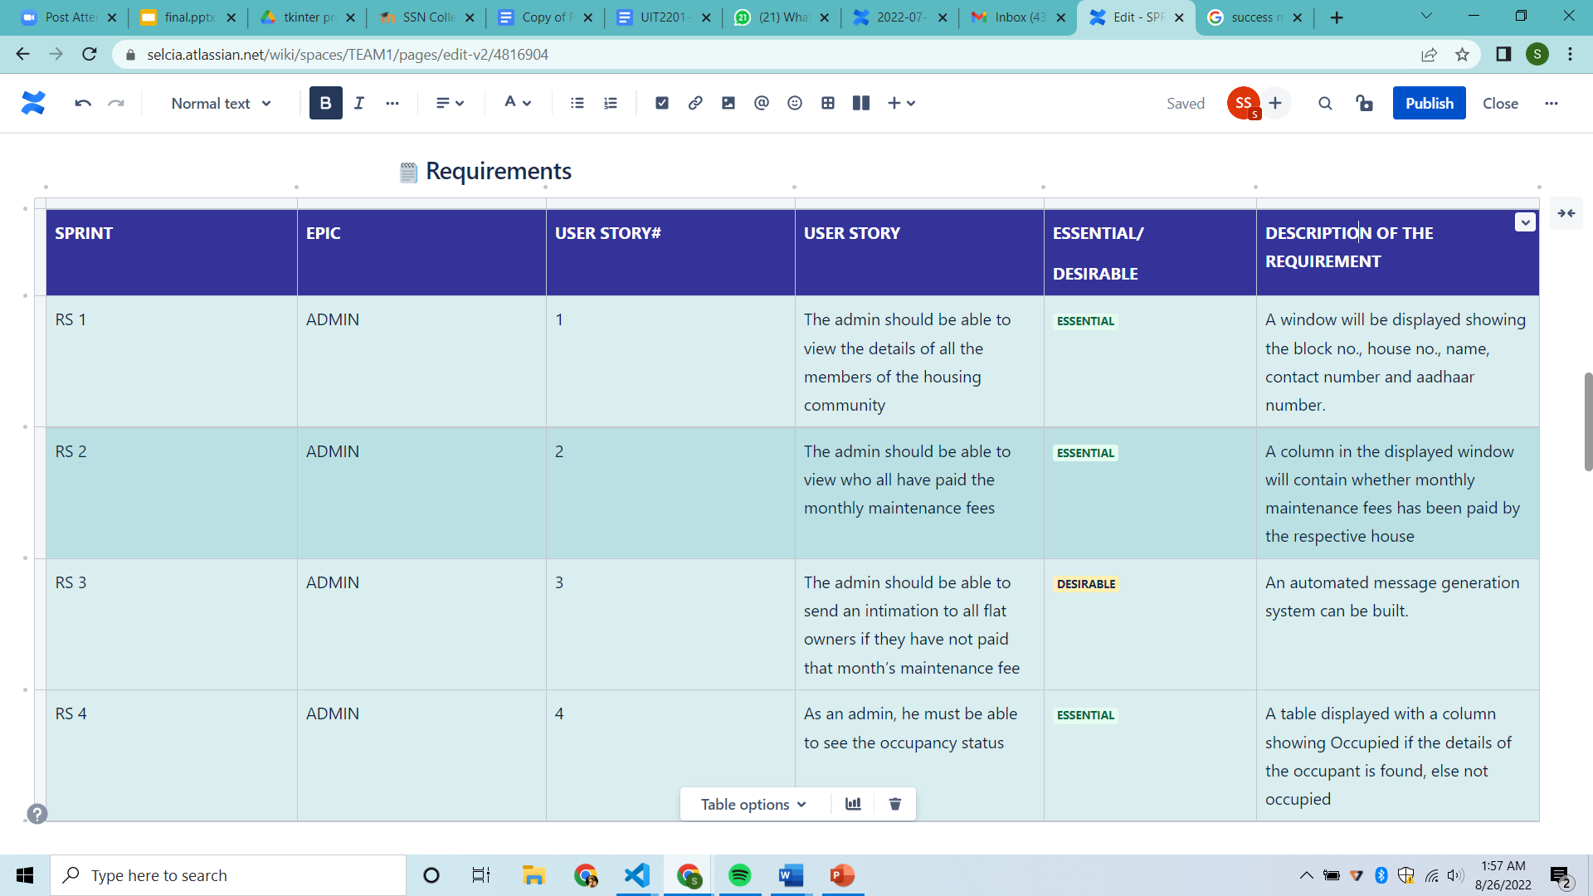

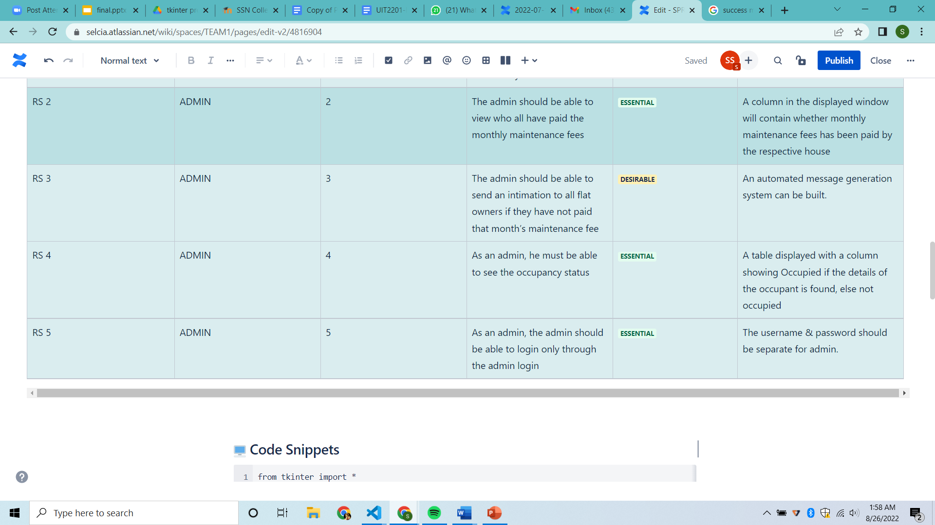

**SPRINT – 02**

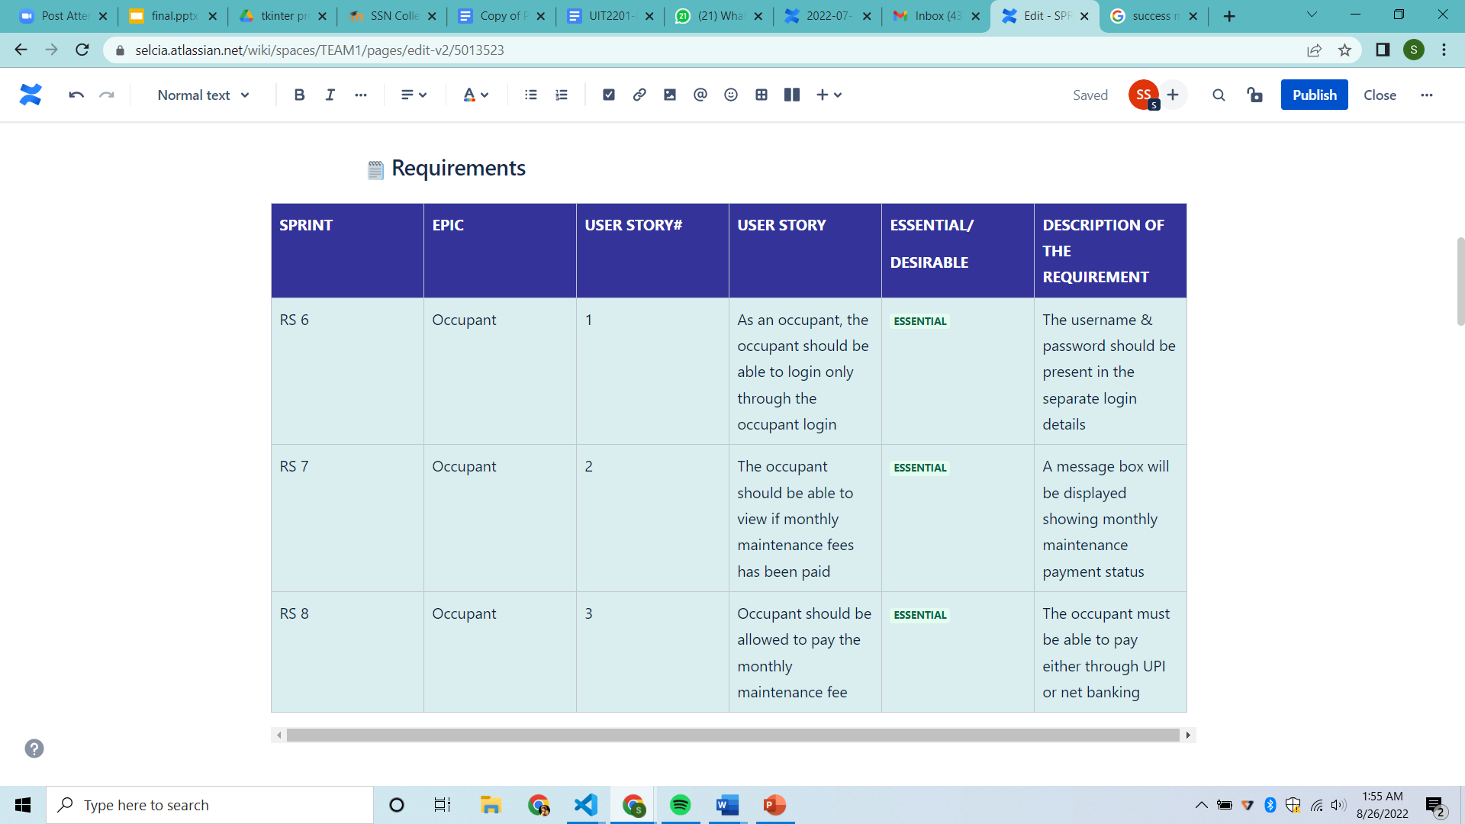

**SPRINT – 03**

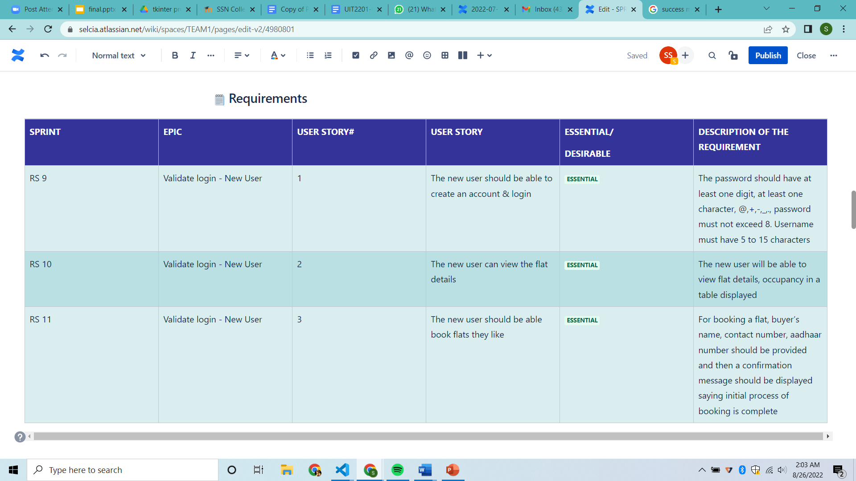

**Objectives**

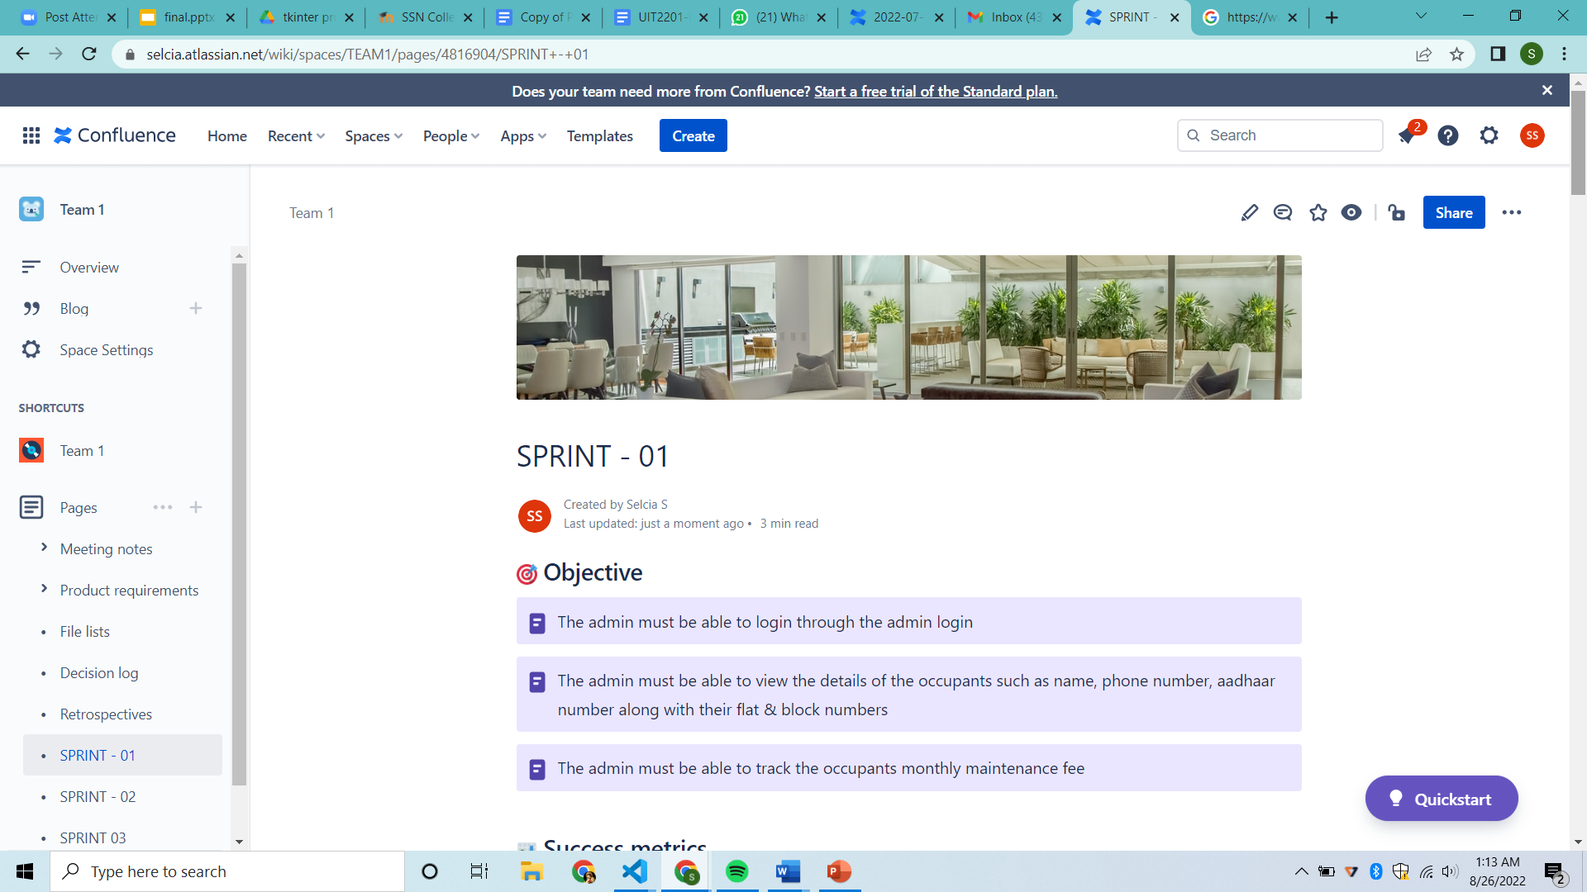

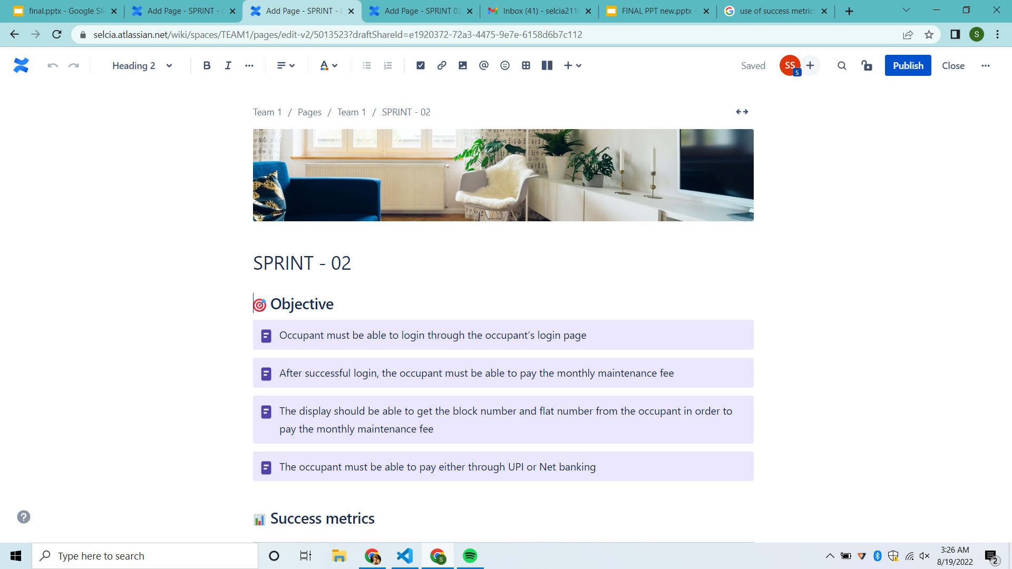

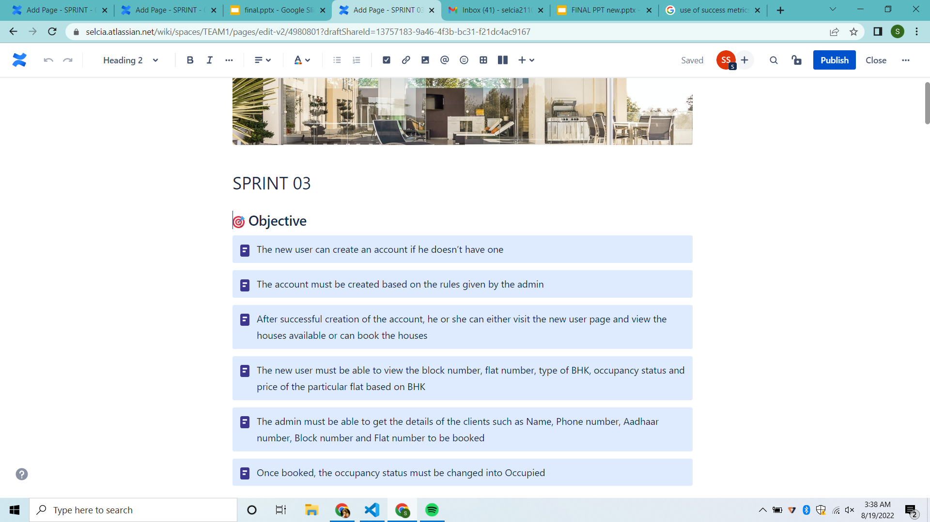

**Success metrics**

It's important to define goals, signals, and **measures** as a team so that everyone knows what a **successful** project looks like. By tracking metrics, we can develop better decision-making, resulting in higher team productivity and customer satisfaction.

**SPRINT – 01**

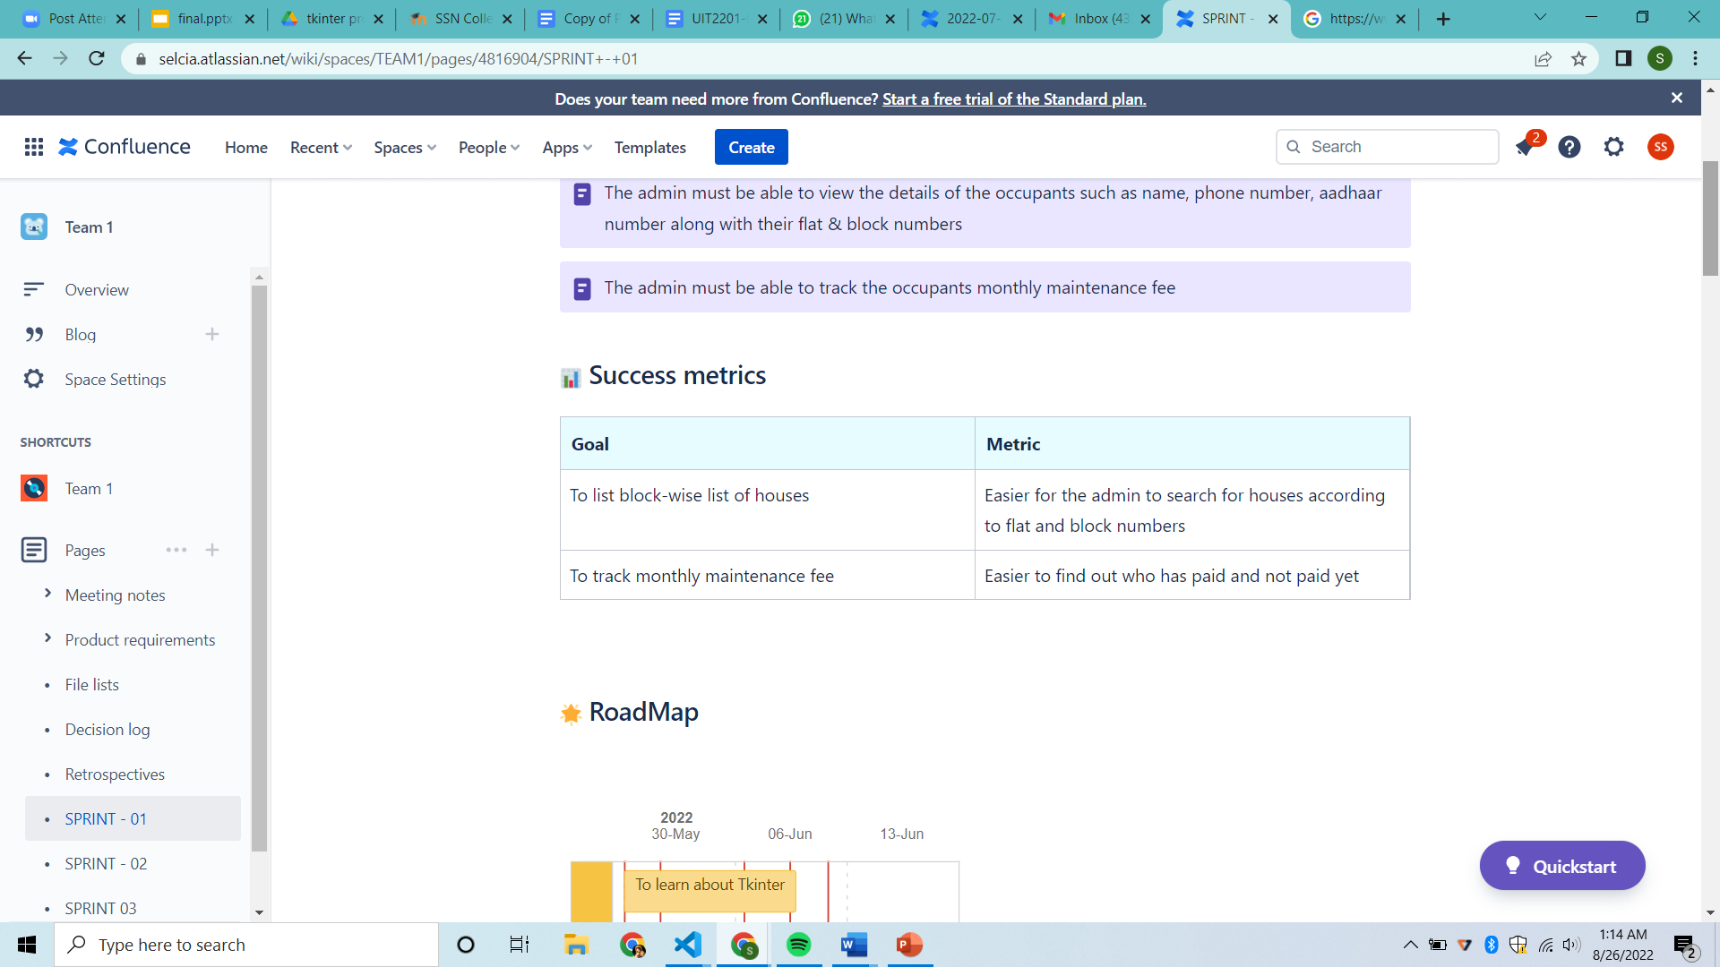

**SPRINT – 02**

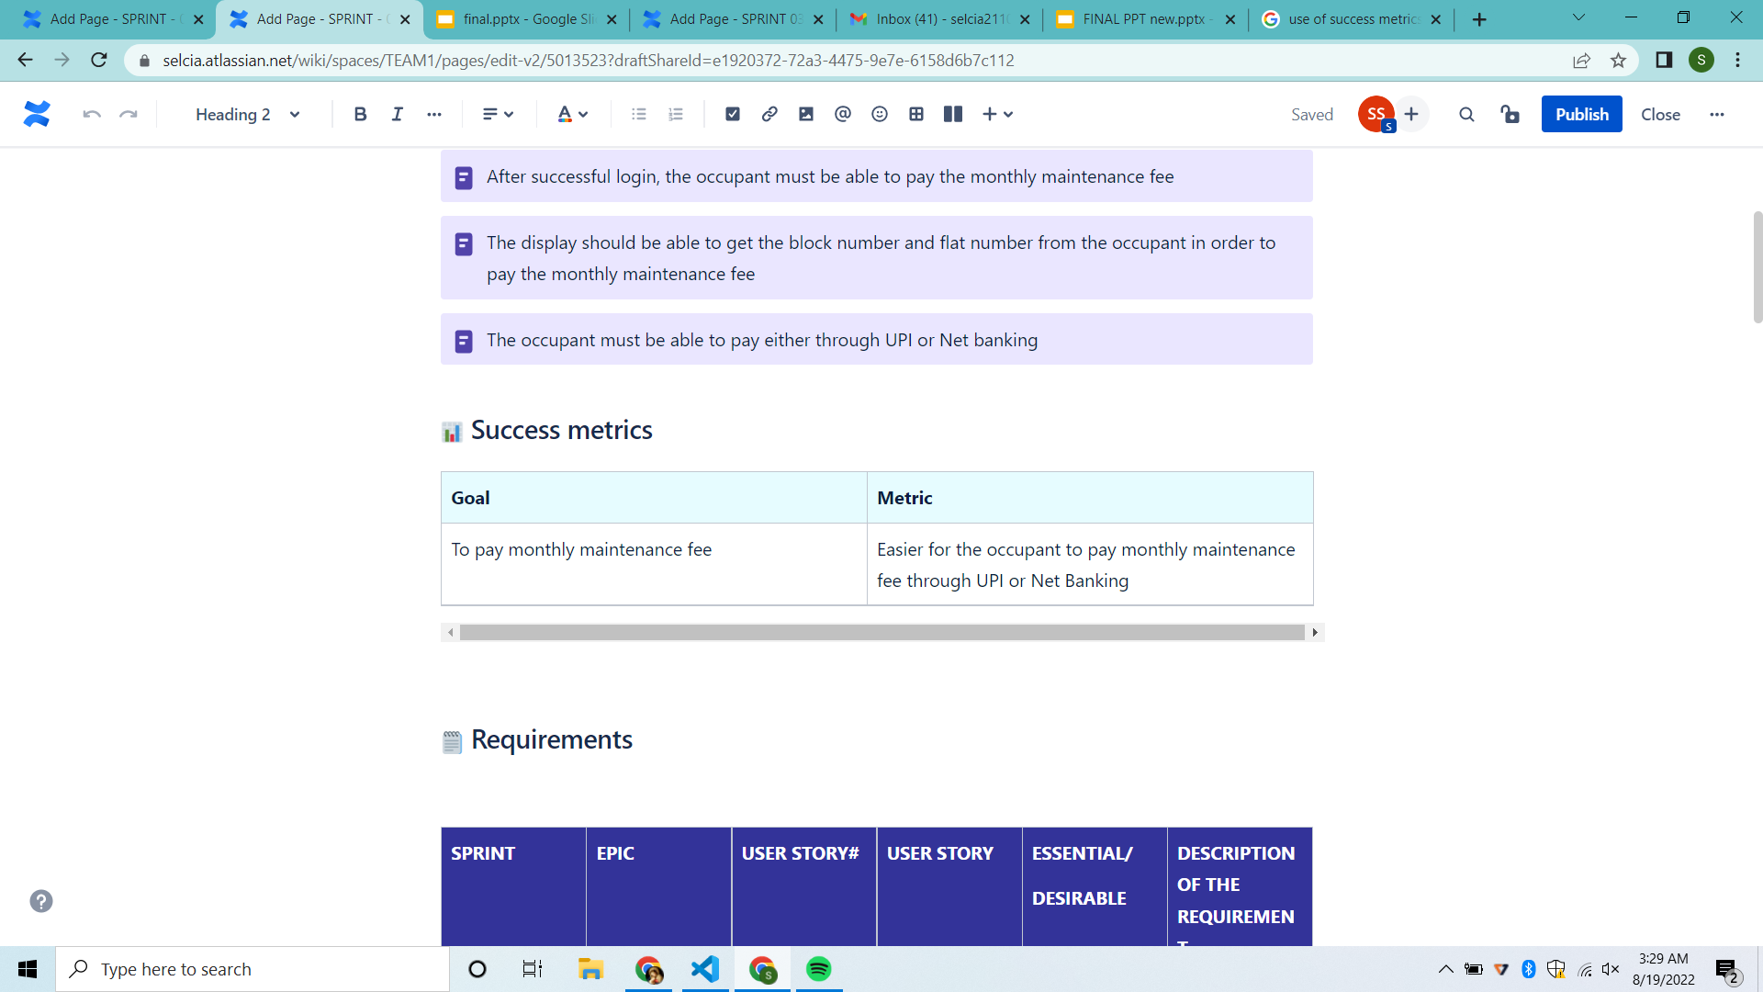

**SPRINT – 03**

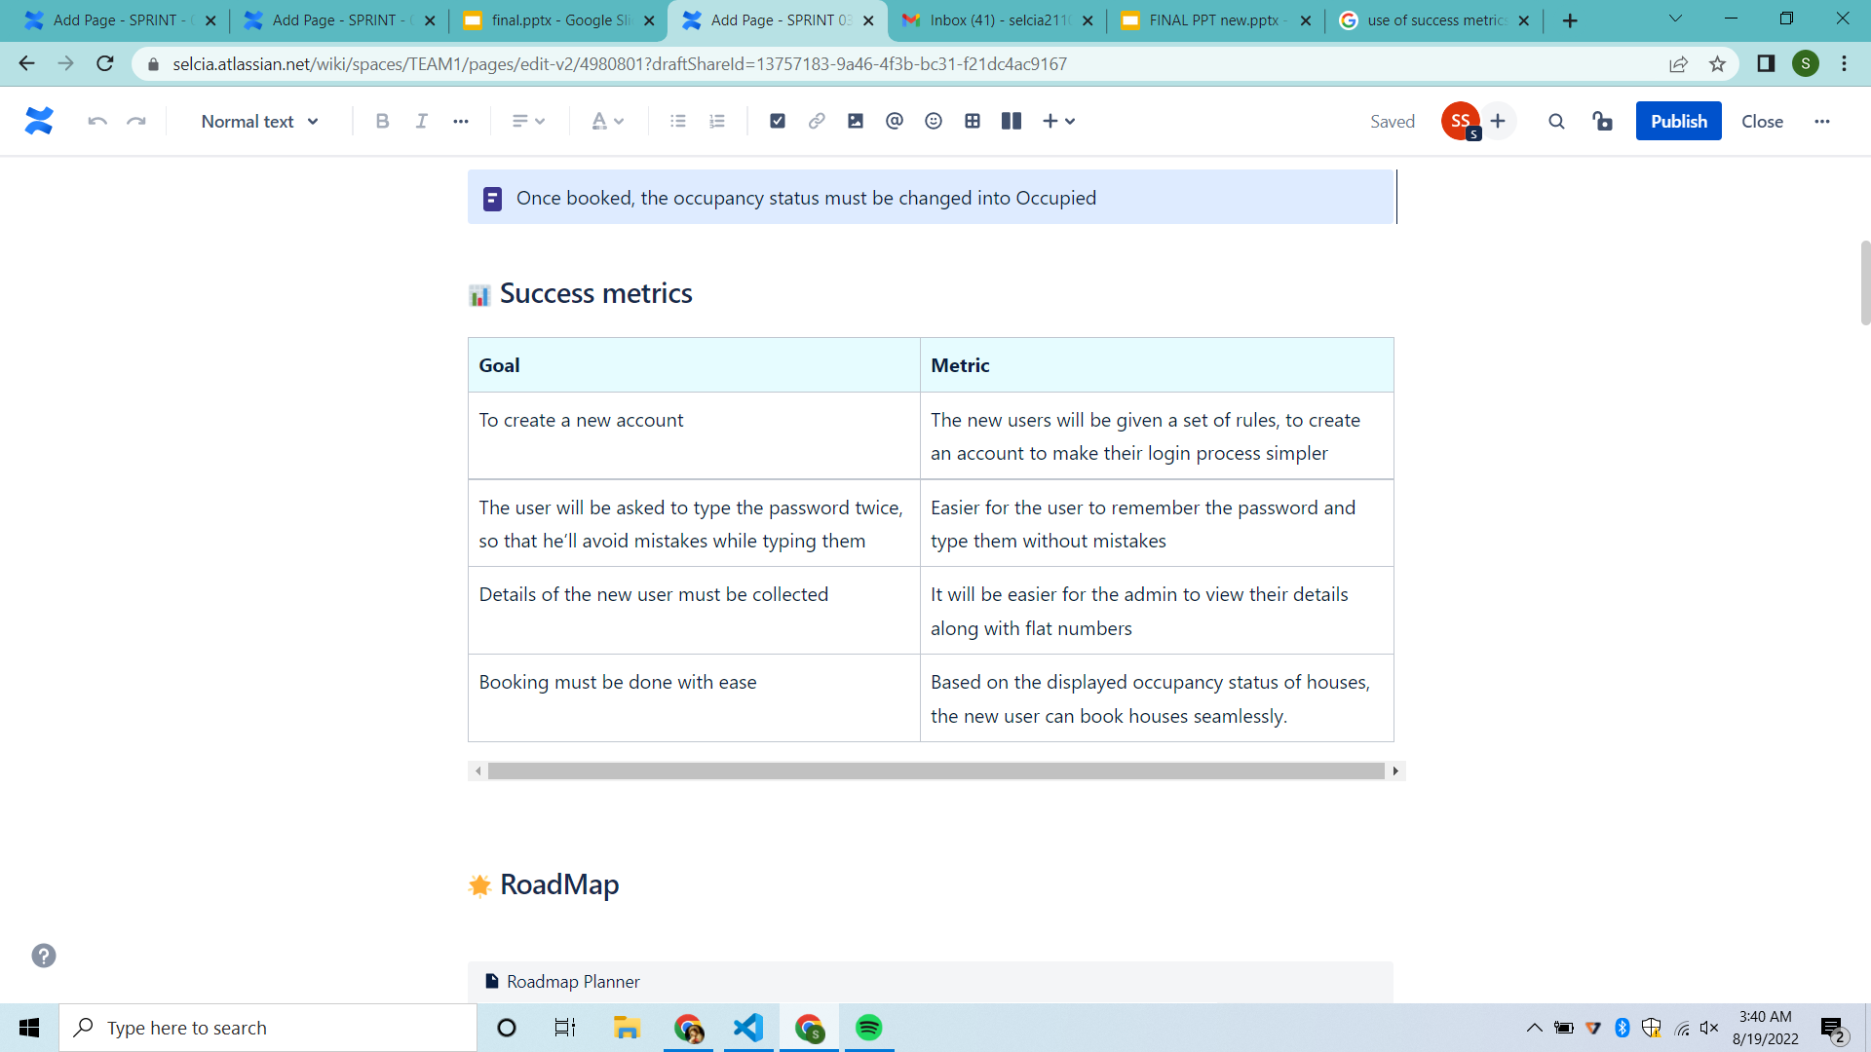

**Roadmap**

By the use of roadmap, we can track our work and keep our team members updated.

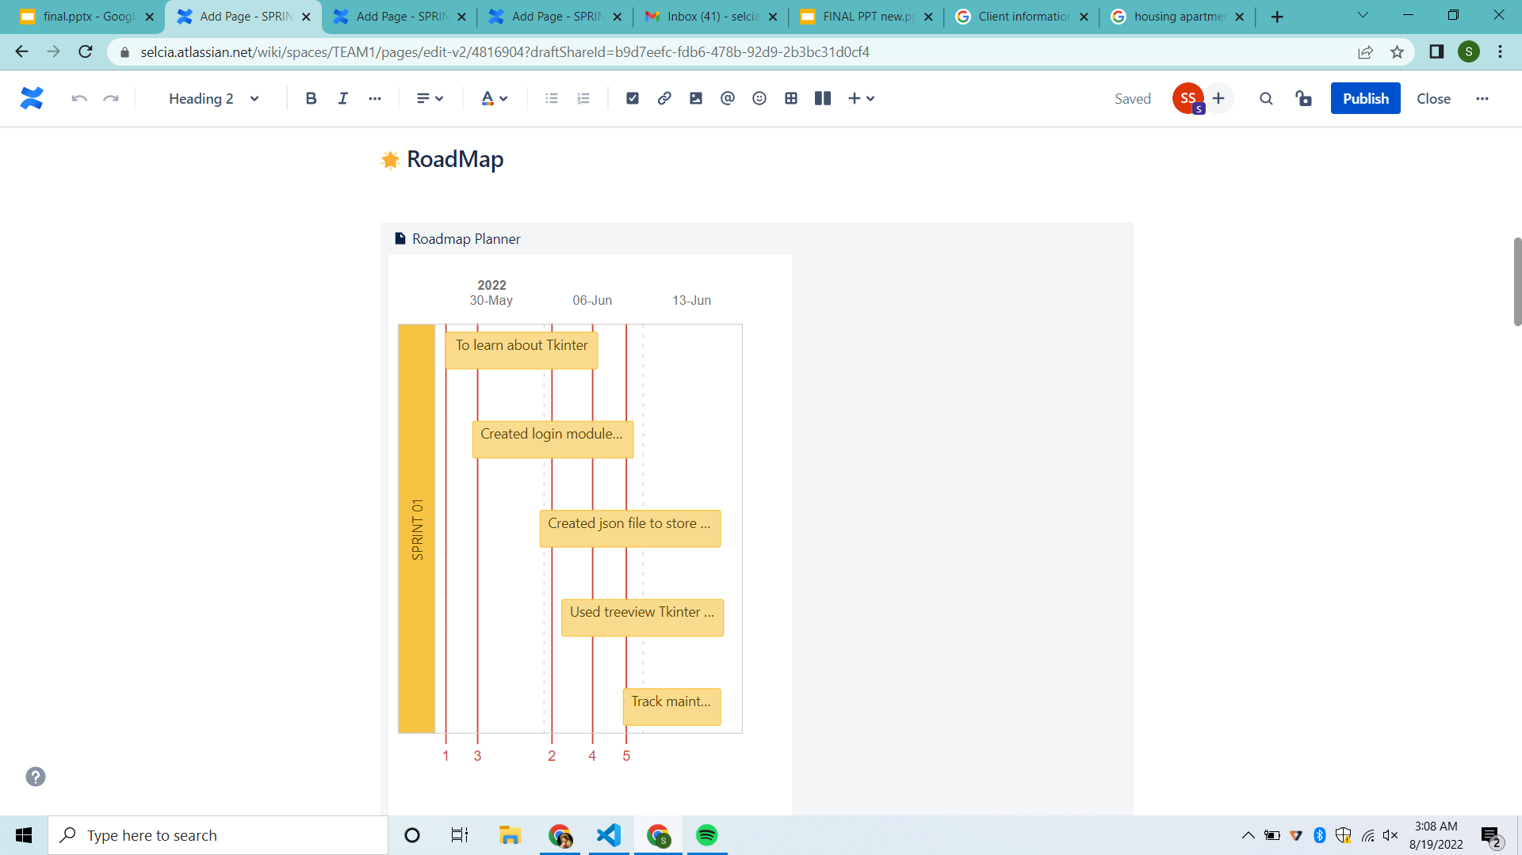  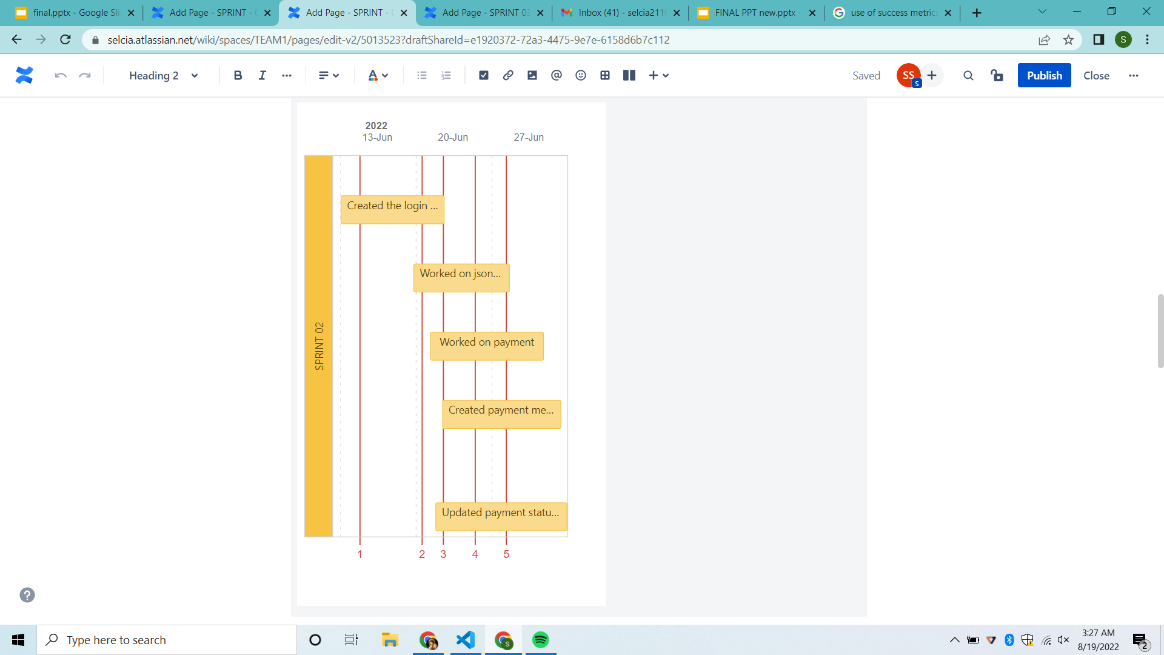

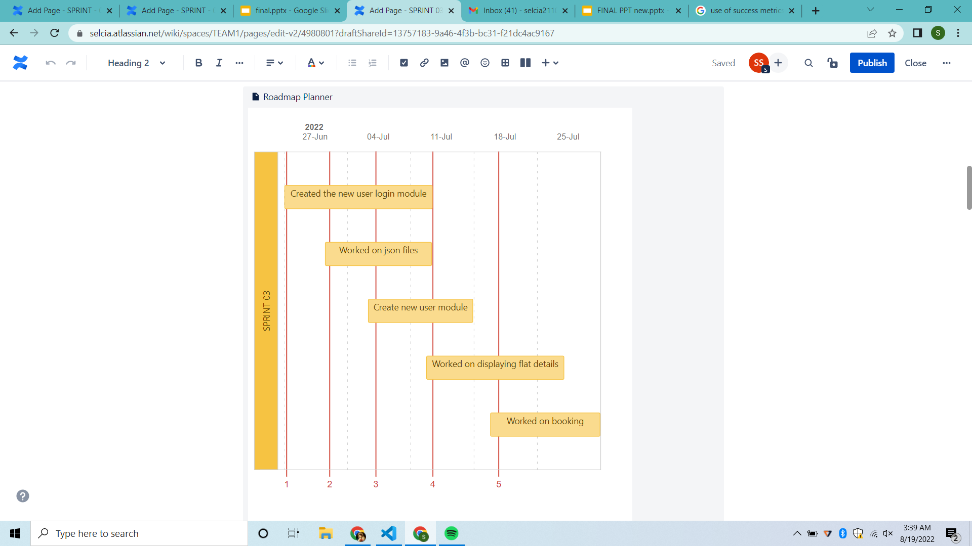

**SPRINT – 01**

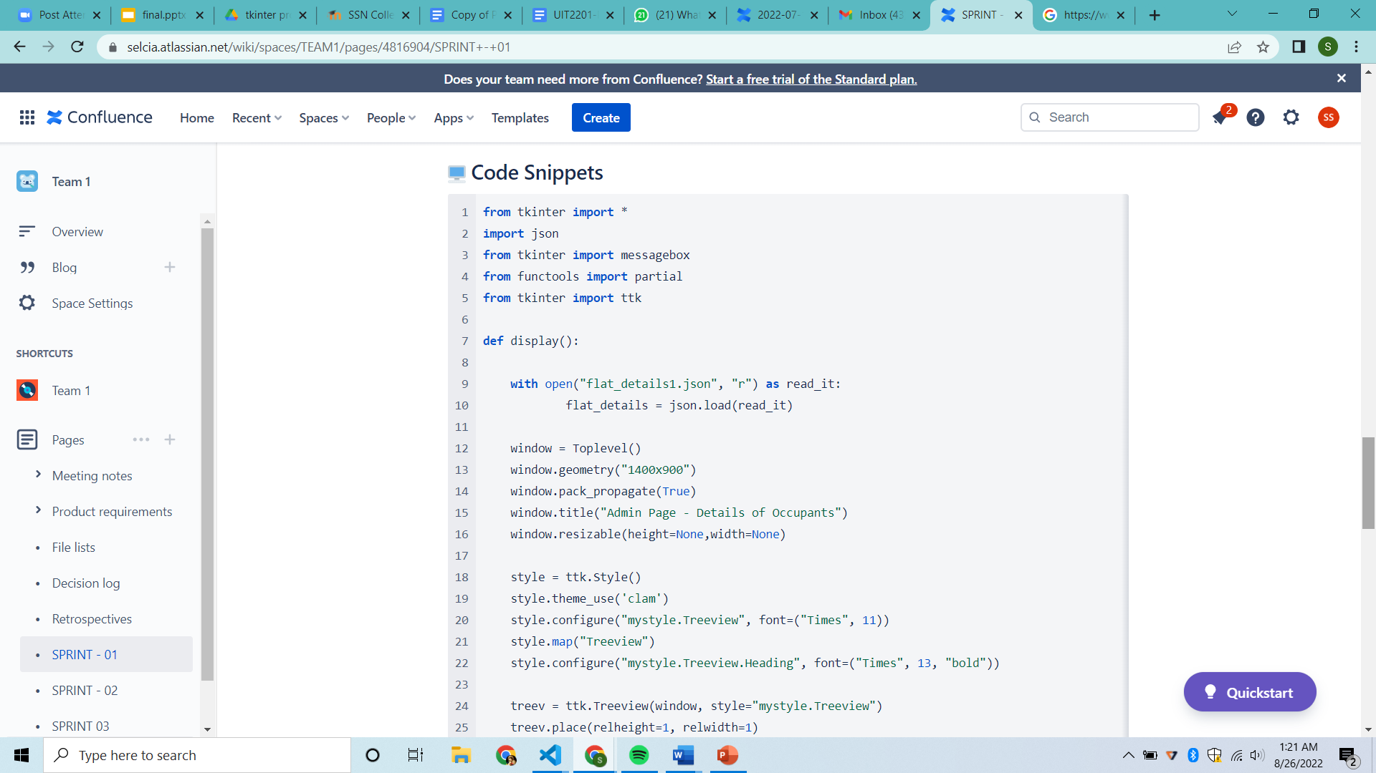

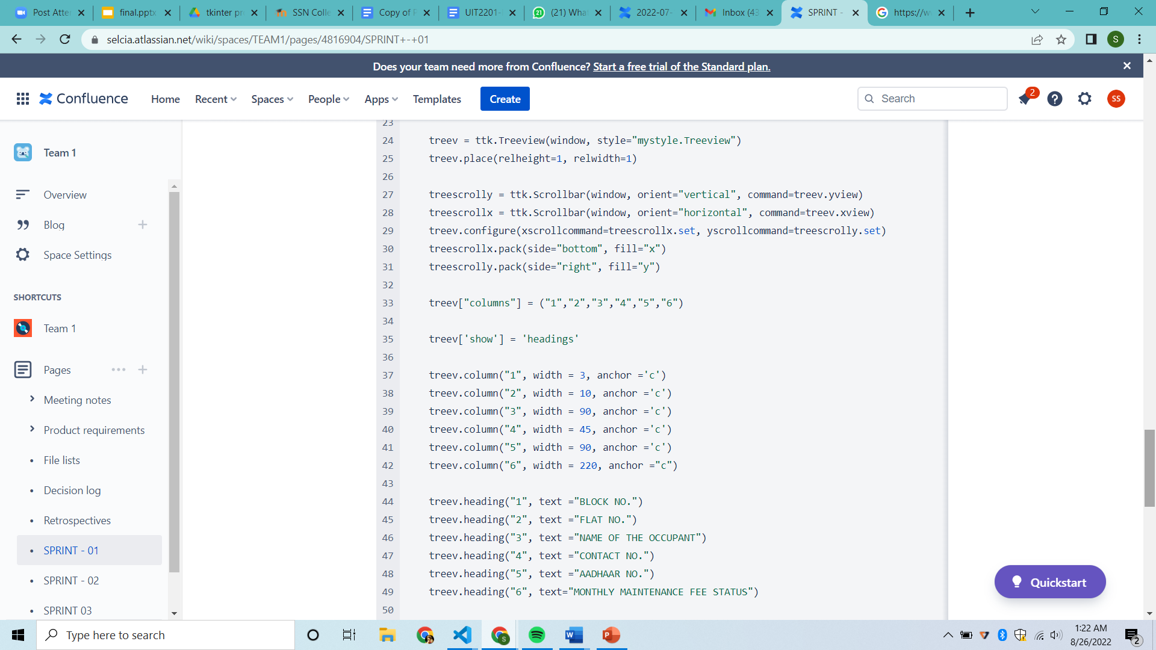

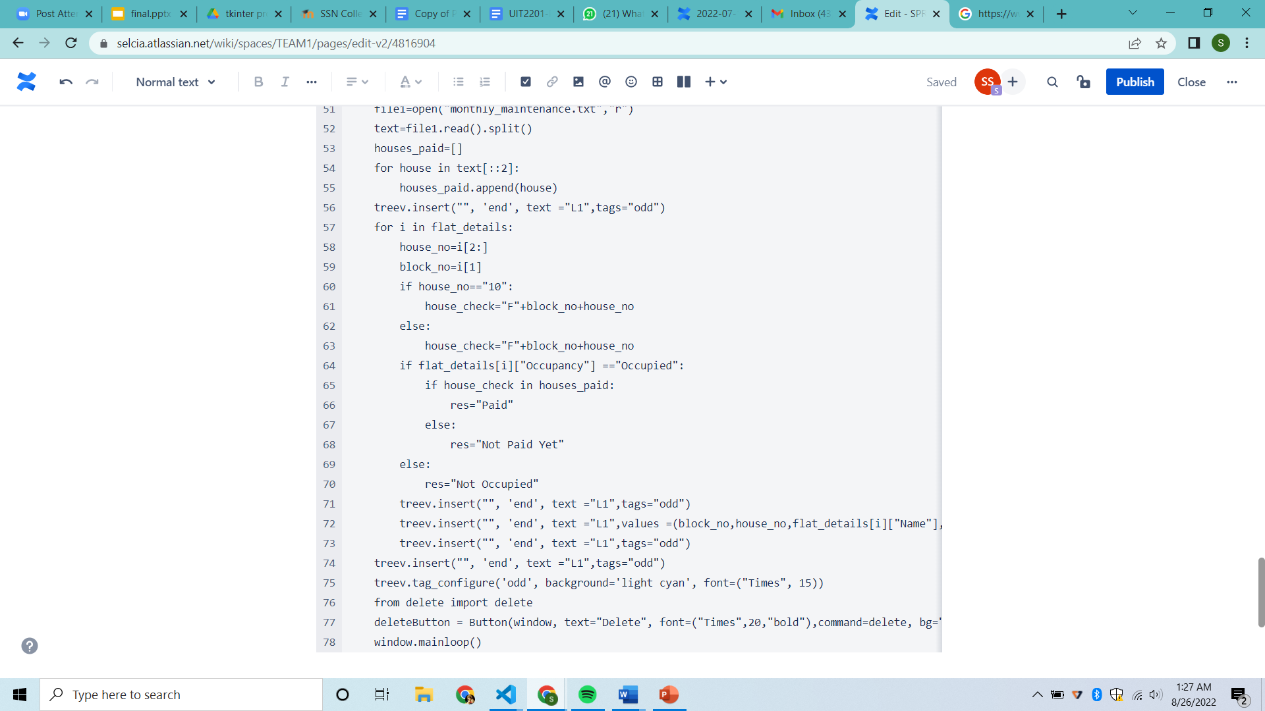

**SPRINT – 02**

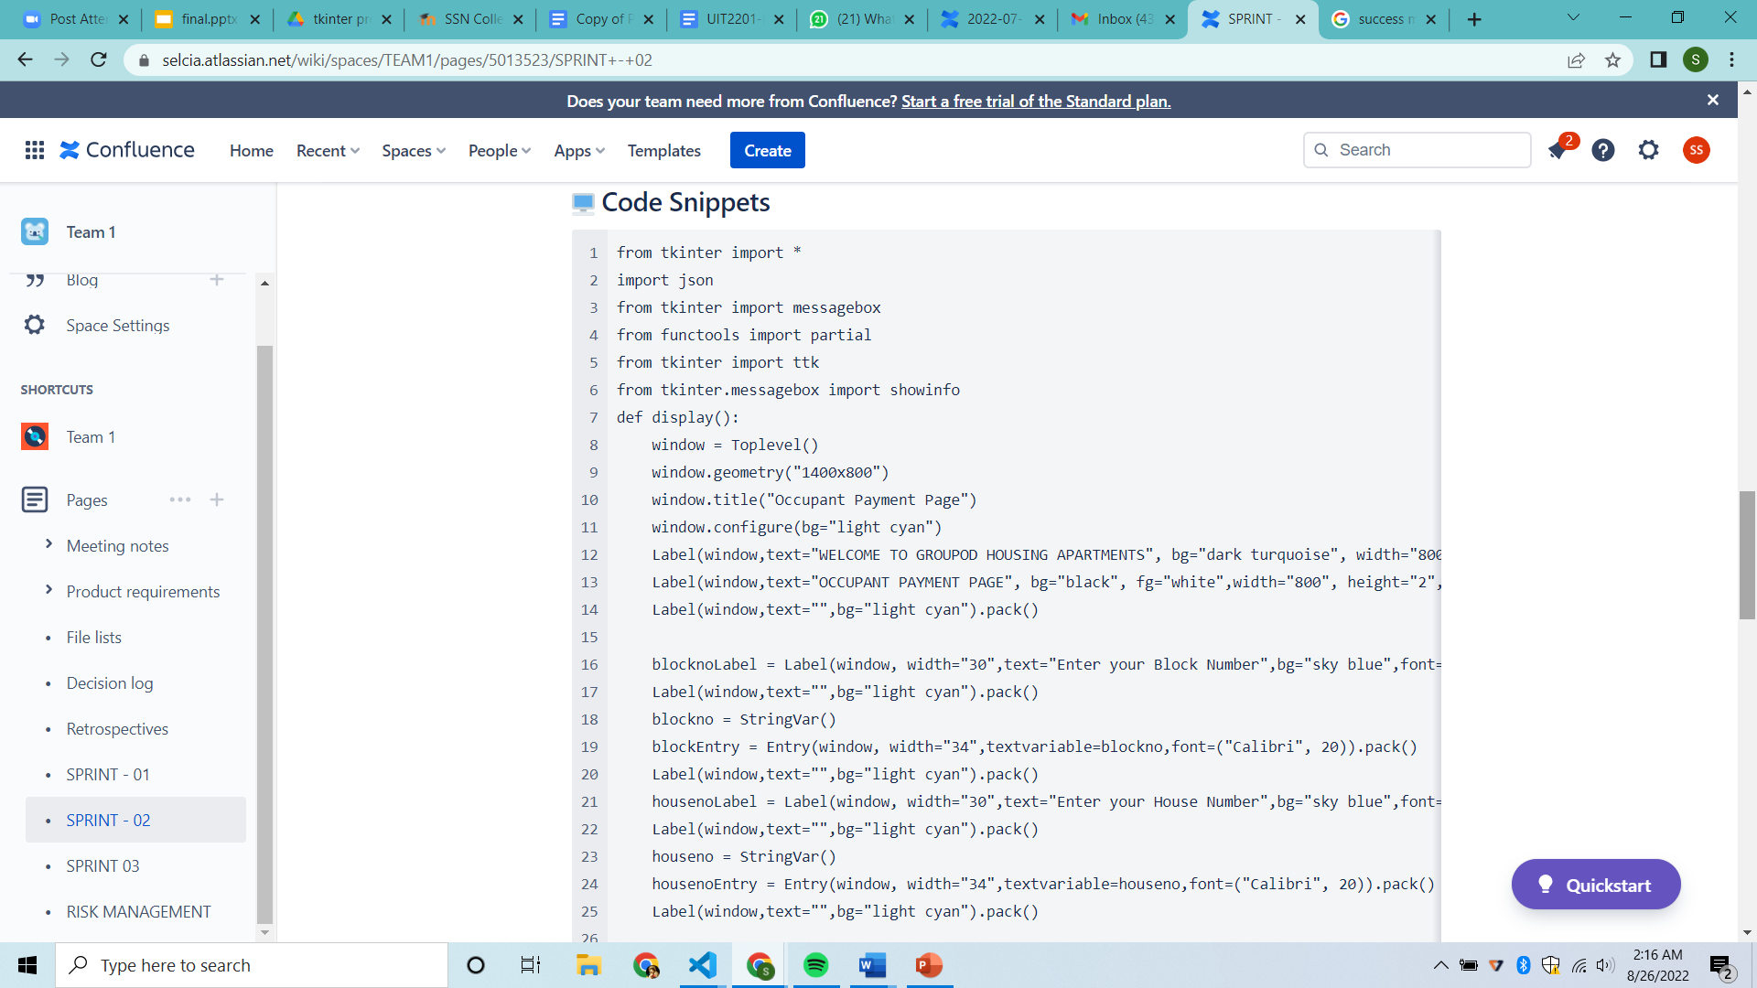

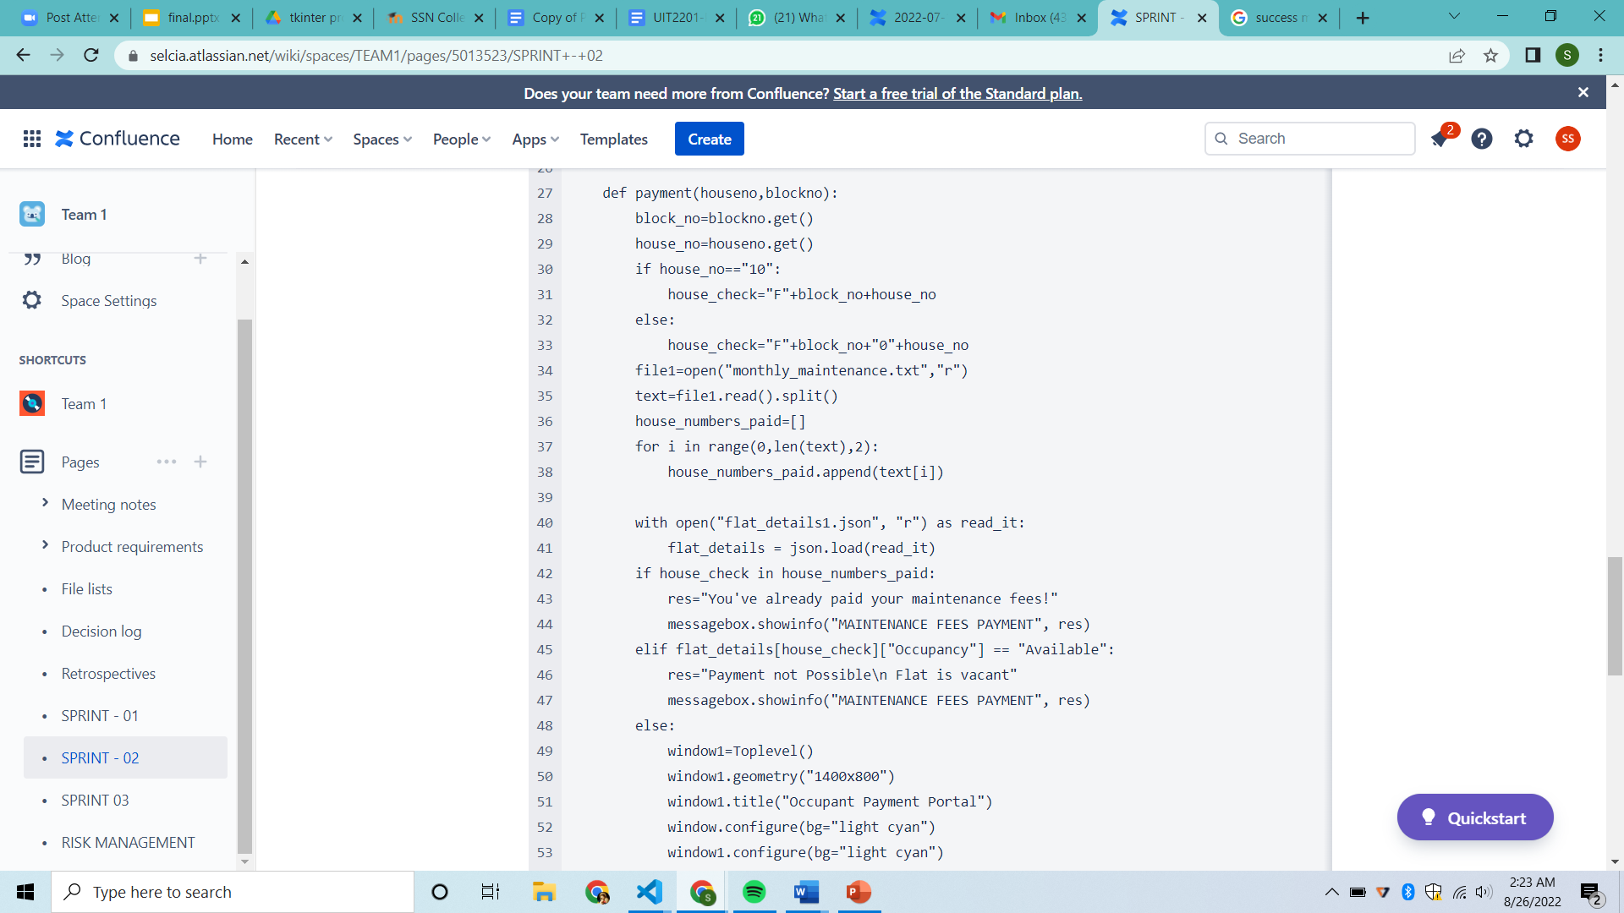



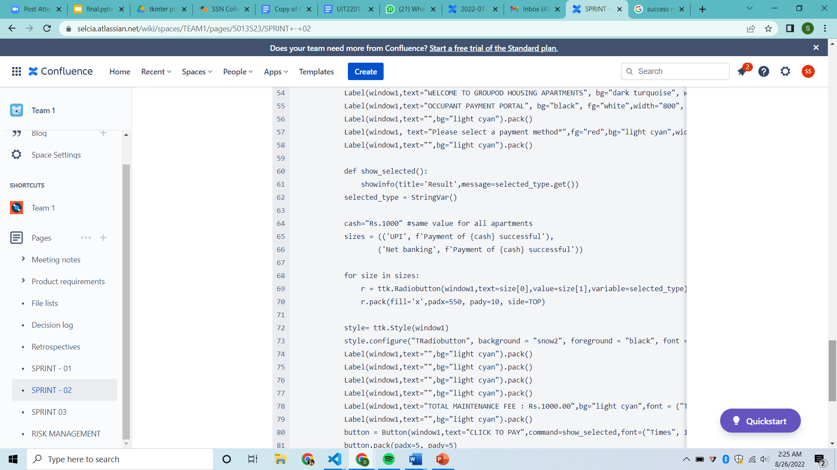

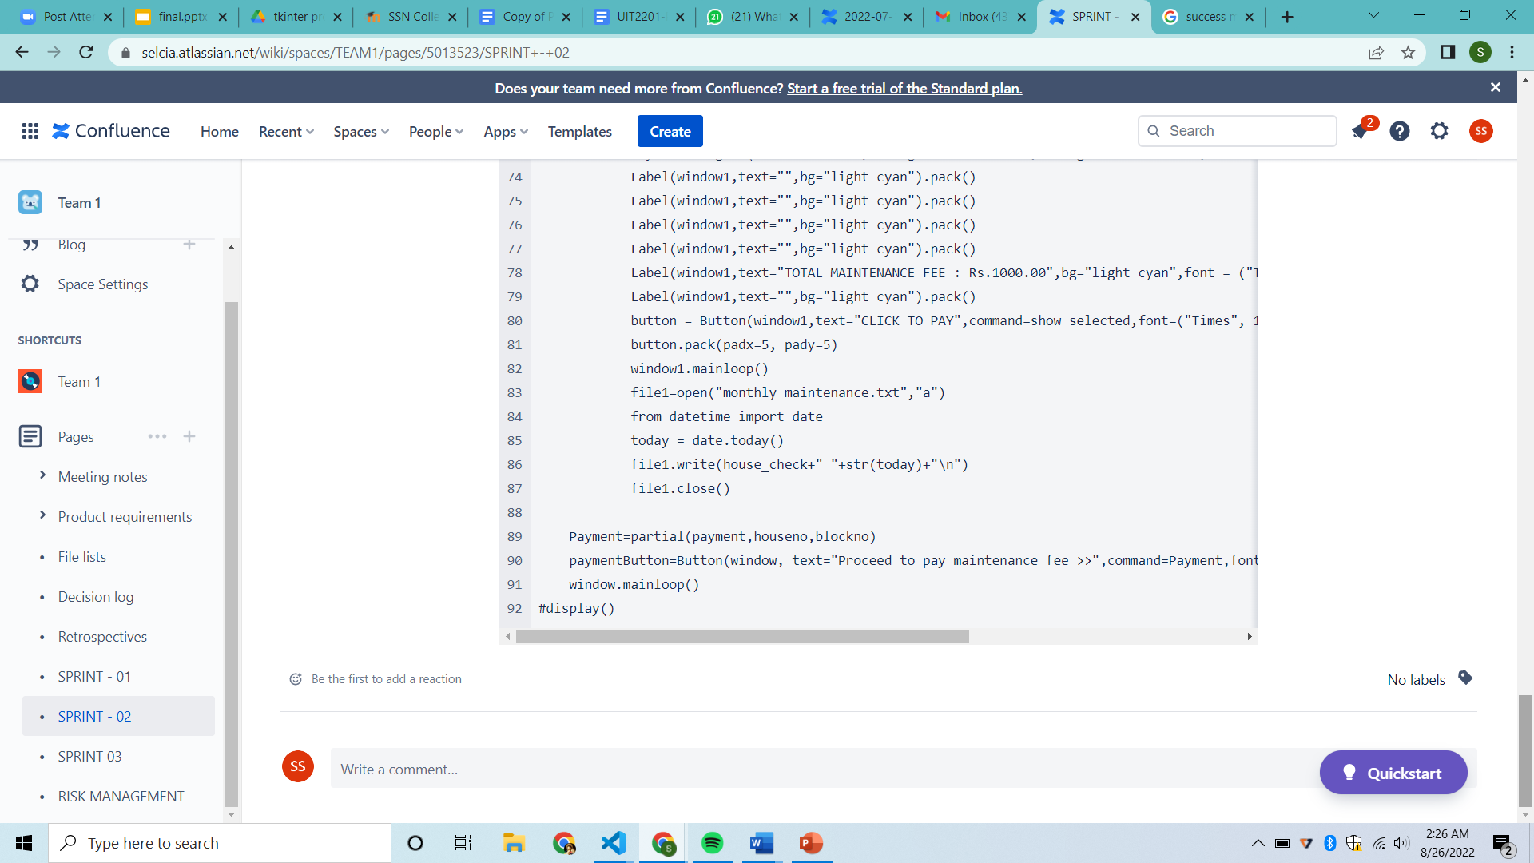

**SPRINT – 03**

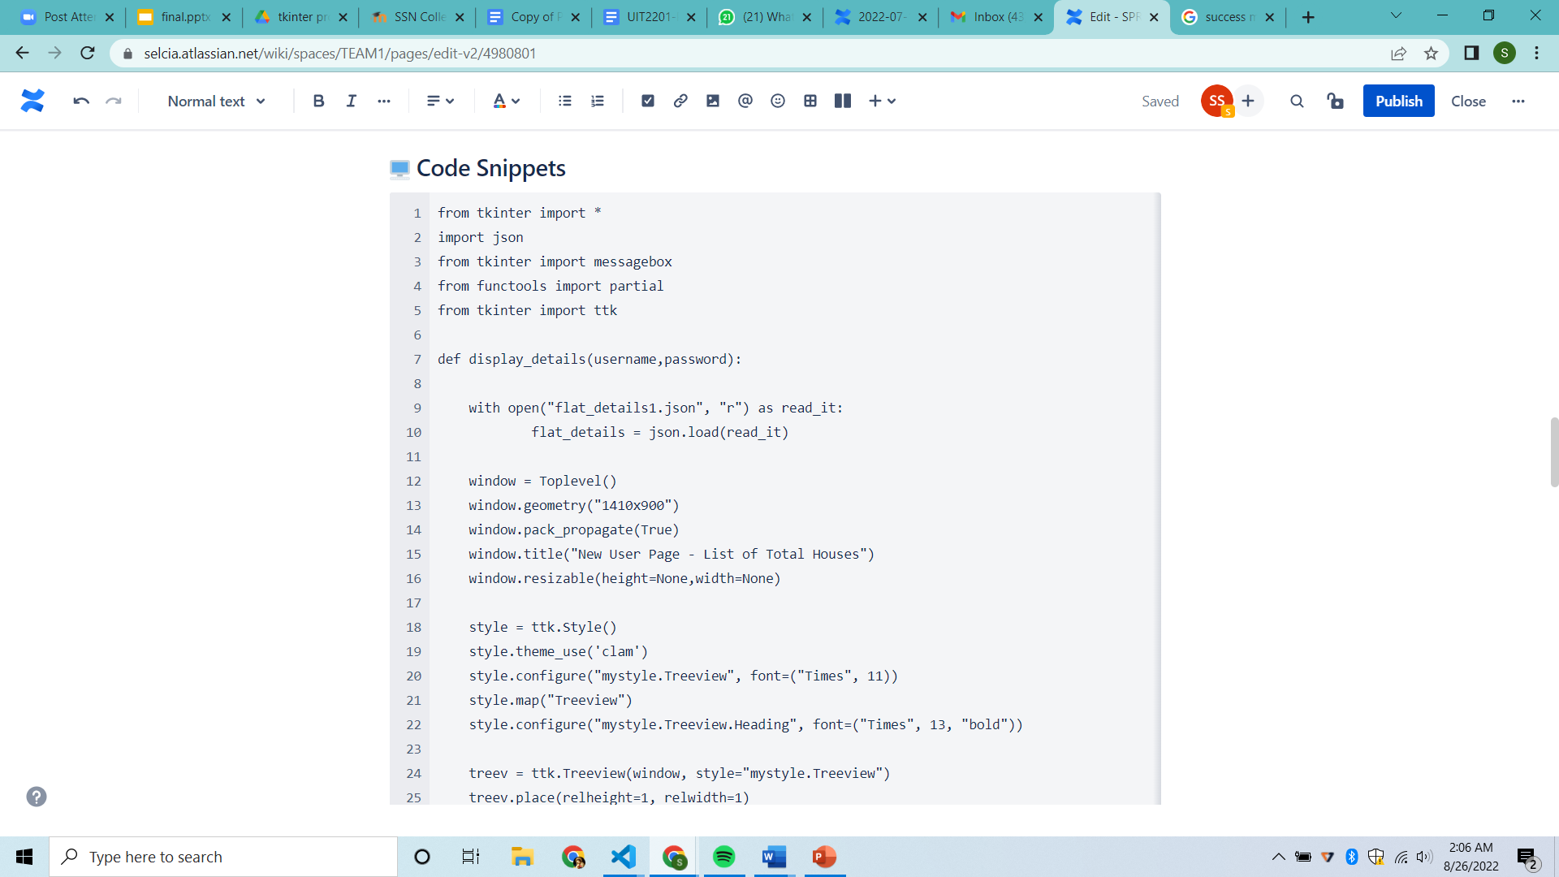

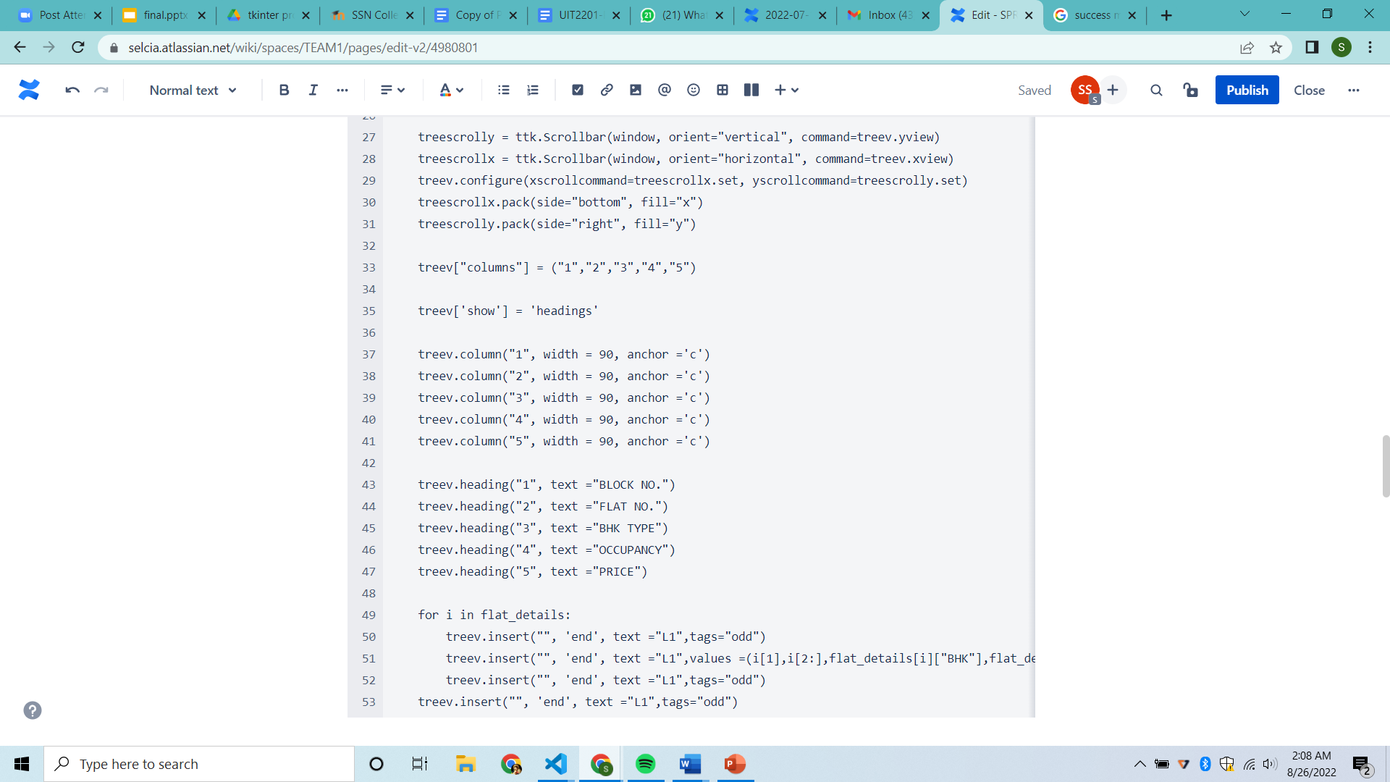

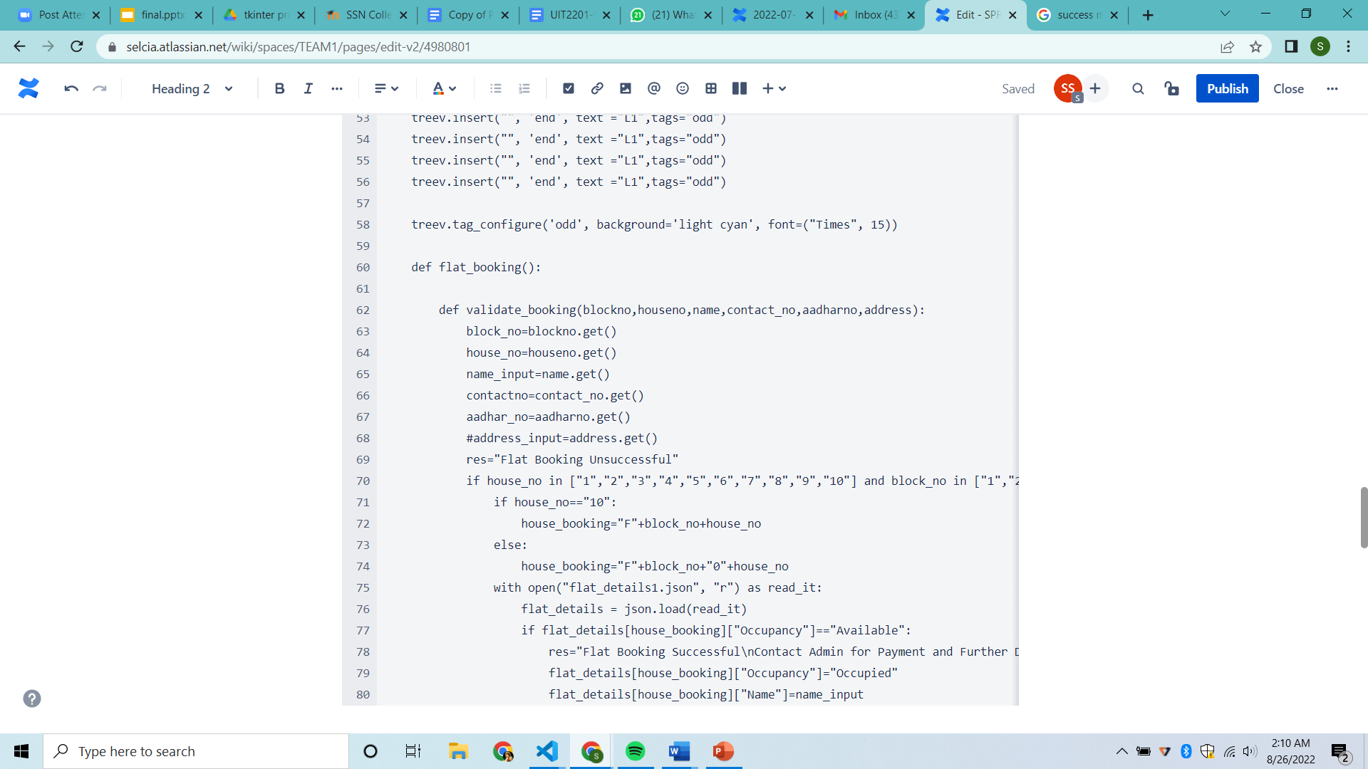

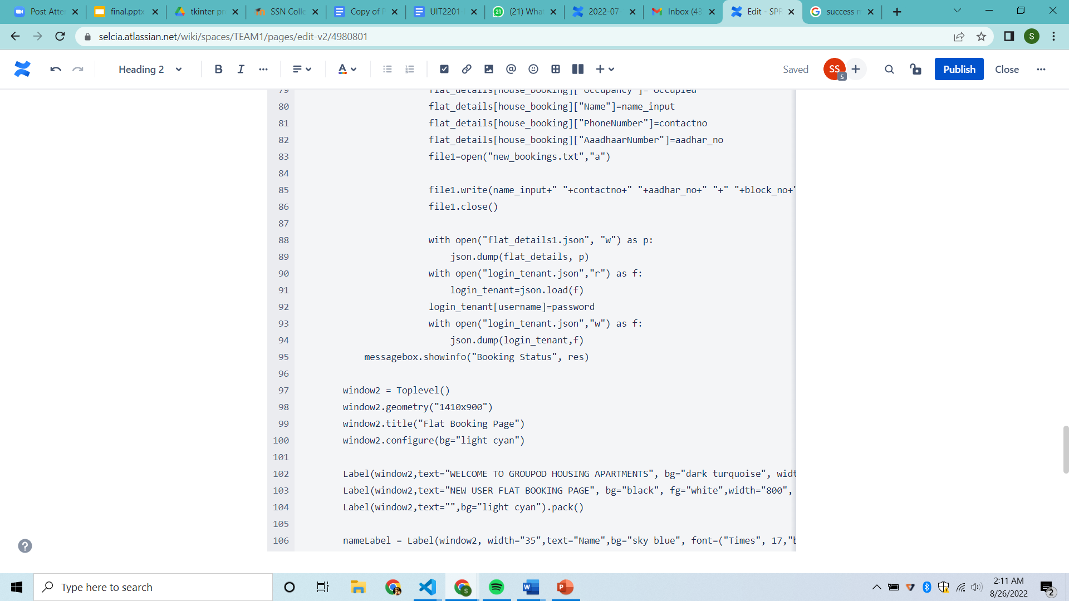

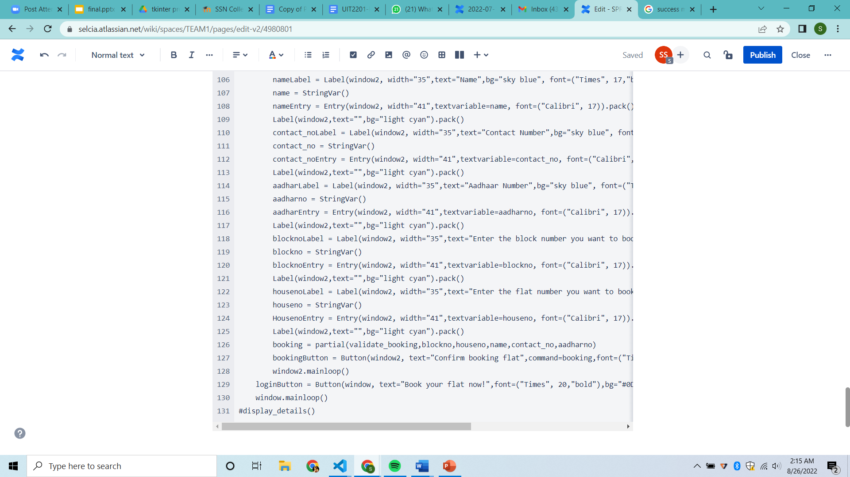

**Meeting Notes**

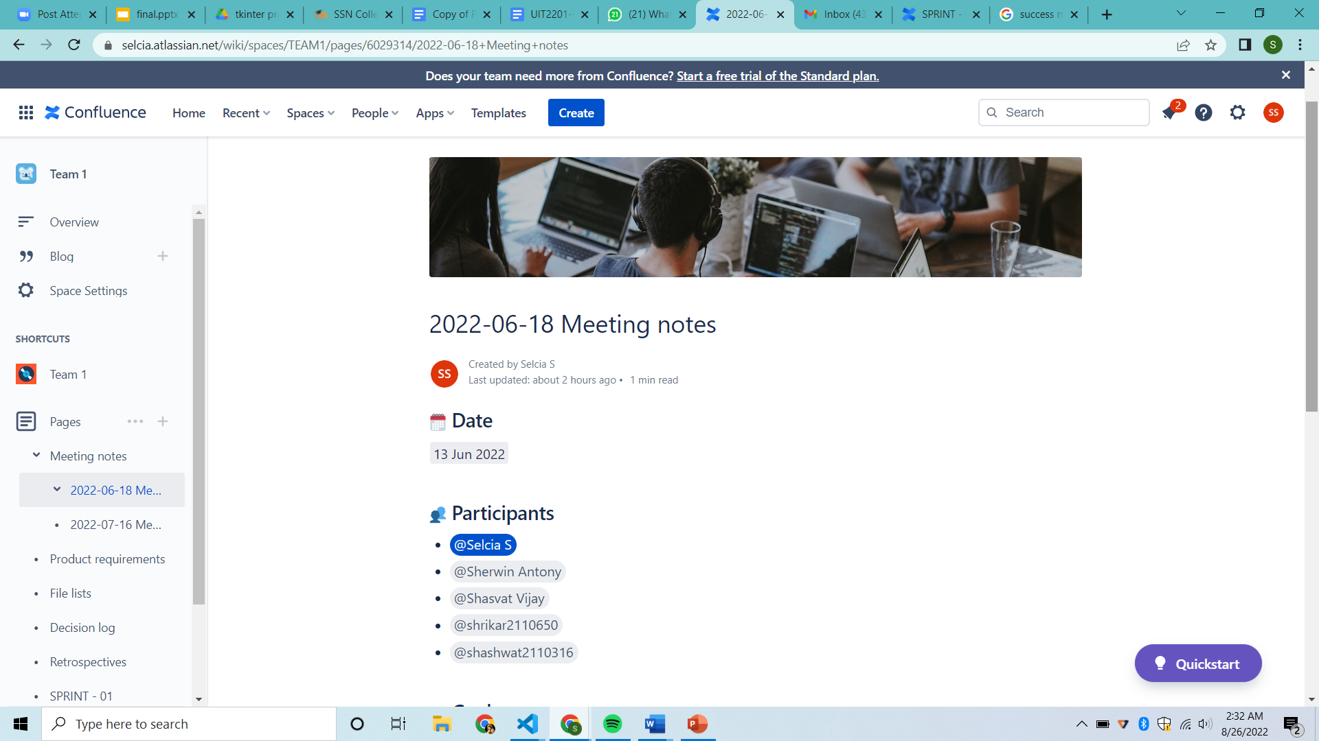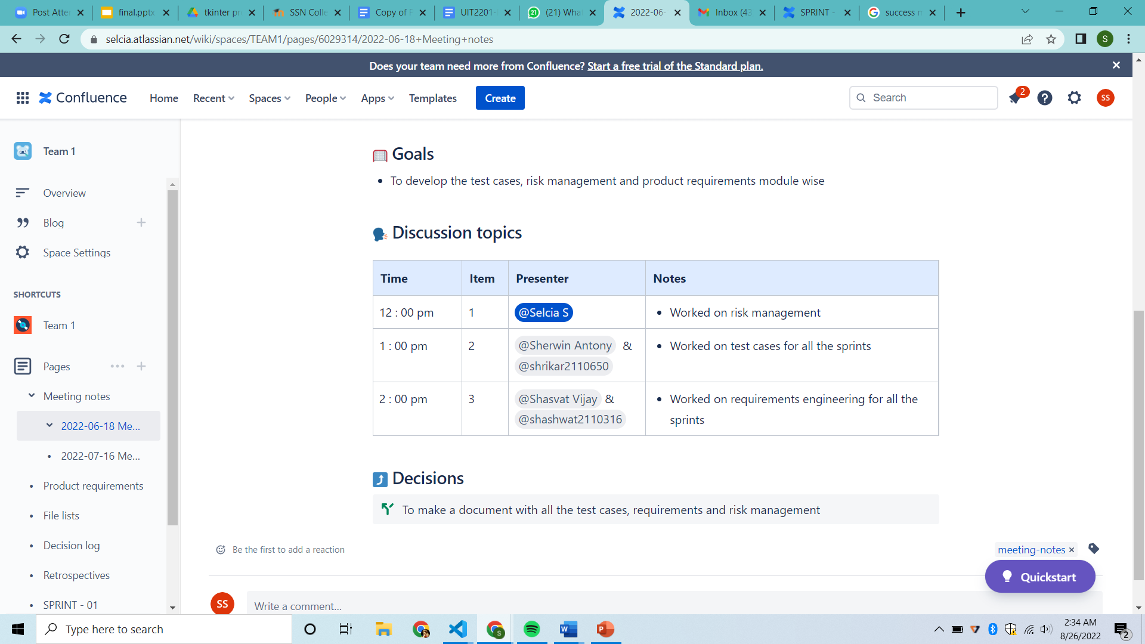

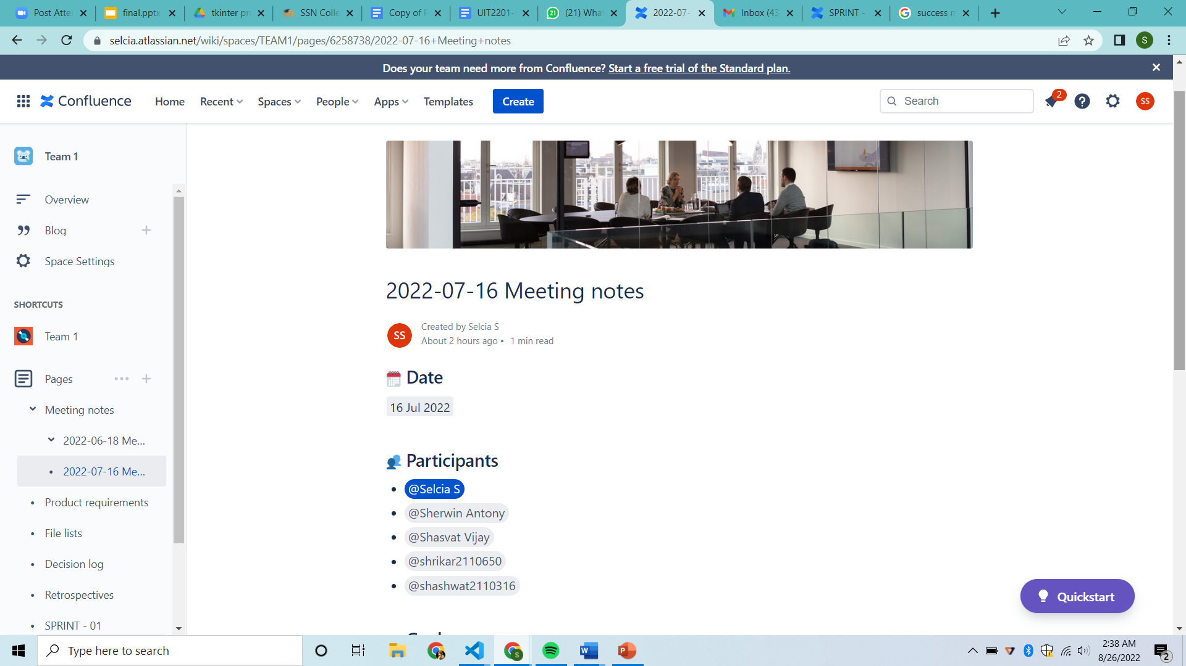

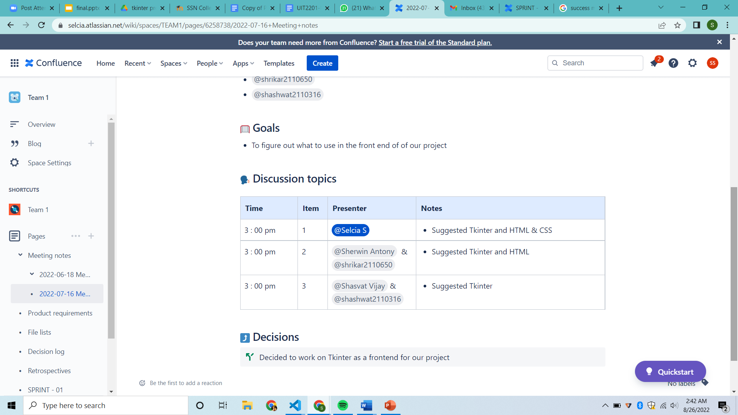

1. **Project outcomes**

This system has three login modules where-in each module has a different functionality.

1. ADMINISTRATOR MODULE

In this module, the administrator will be able to login and manage the whole system in an effective and efficient manner.

1. OCCUPANT MODULE

In this module the occupants who’ve already bought the house & are residing in it will be able to login and pay their monthly maintenance fee.

1. NEW USER MODULE

In this module the user can create an account if he doesn’t have one and allows him to login if he’s an existing user.

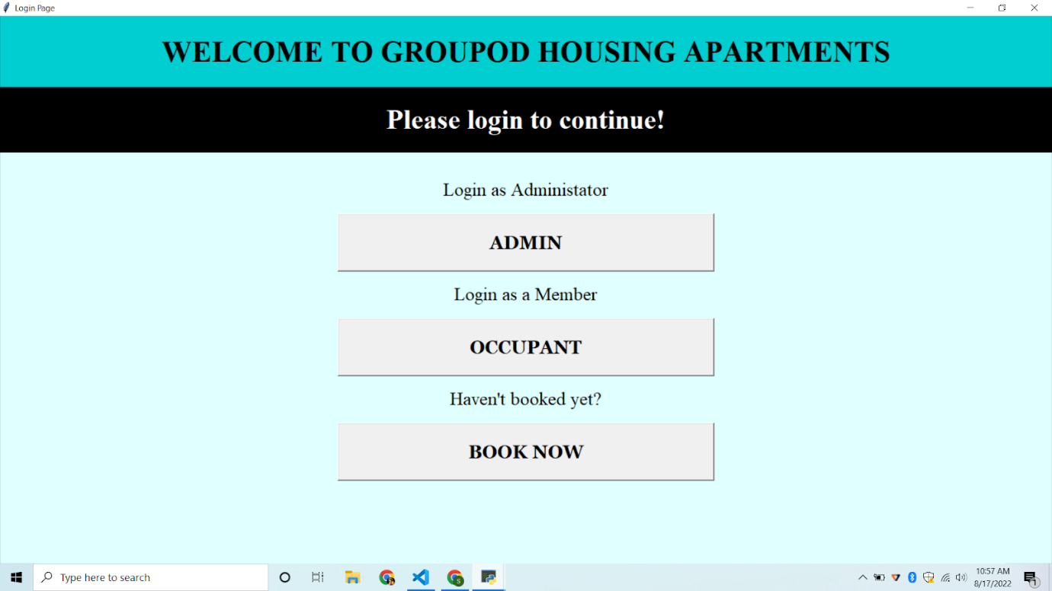

Implementation of Admin Module :

* Here’s a list of block wise list of flat numbers with the occupant details, flat number, block number, name, mobile number and state of occupancy.
* Once the system administrator logins, he’ll be able to view the details as mentioned above.
* He can view the details of the occupants’ payment status as well.
* Thus, the system can generate a block wise list of occupant details which will make it easy for the administrator to manage the housing community.

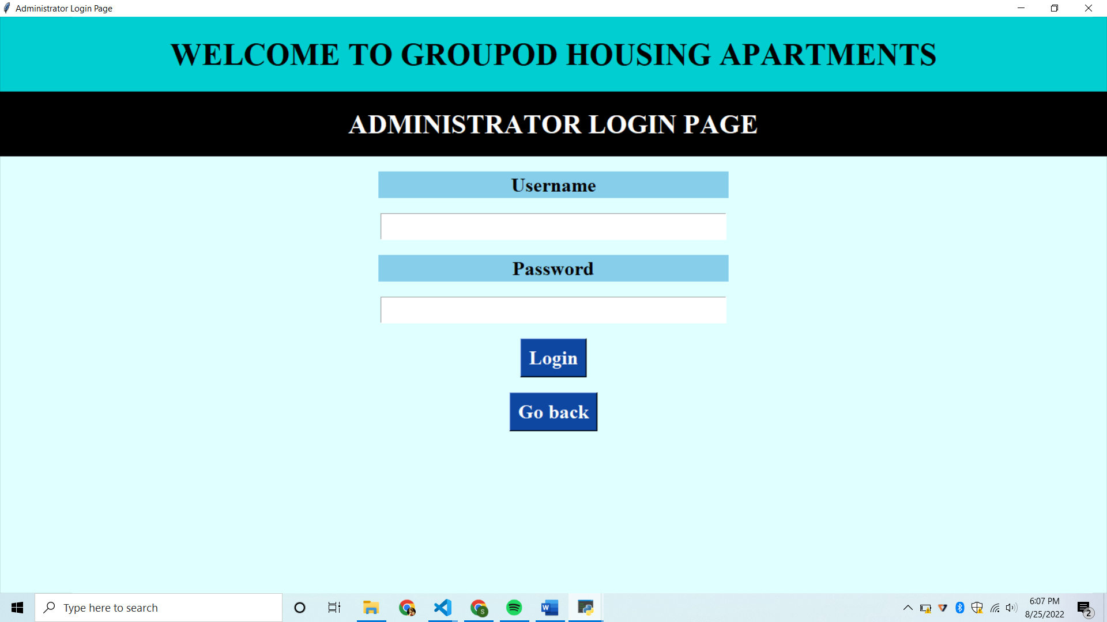

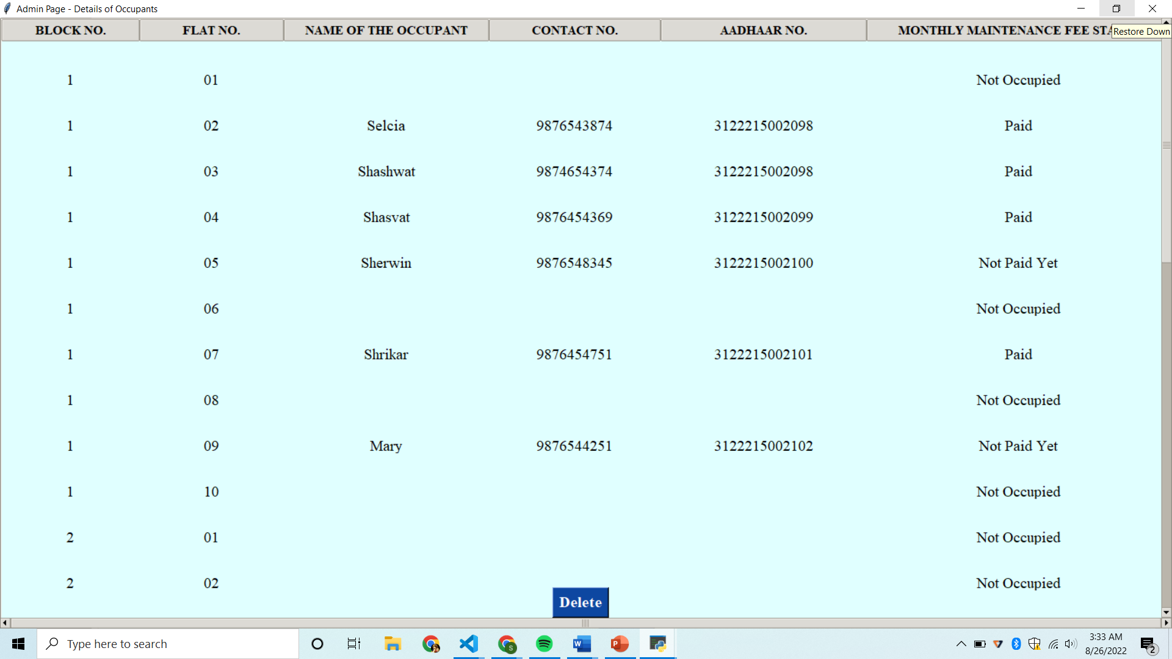

* With JSON files as a backend to store data and Python’s Tkinter as the frontend this module was developed.
* First, we validate the admin’s login and allow the administrator to view the client details
* Here we’ve used tkinter’s module named Treeview tkinter to establish a table with all the required content.
* Also, the admin can let an occupant vacate by clicking on “Delete”

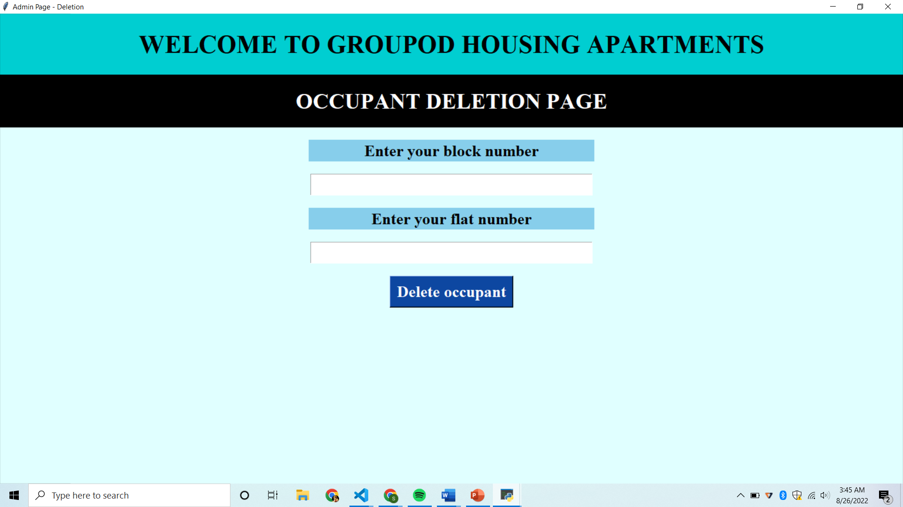

IMPLEMENTATION OF OCCUPANT MODULE

* Once the system occupant logins, he’ll be asked to give his block number and flat number.
* If the entered flat number and block number is correct then the payment portal will be opened.
* Then the occupant will be asked to select the payment option to proceed further.
* The payment will be successful when the occupant clicks the “Click To Pay” button.

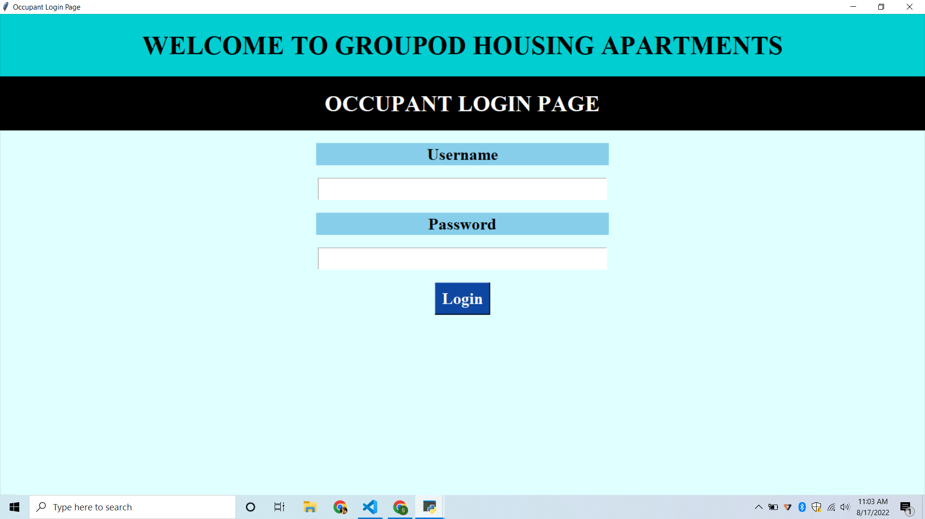

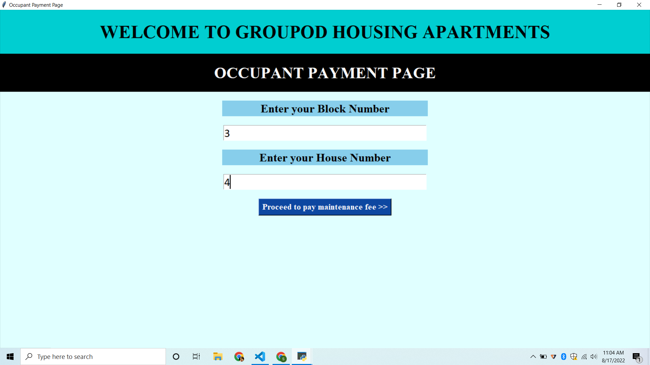

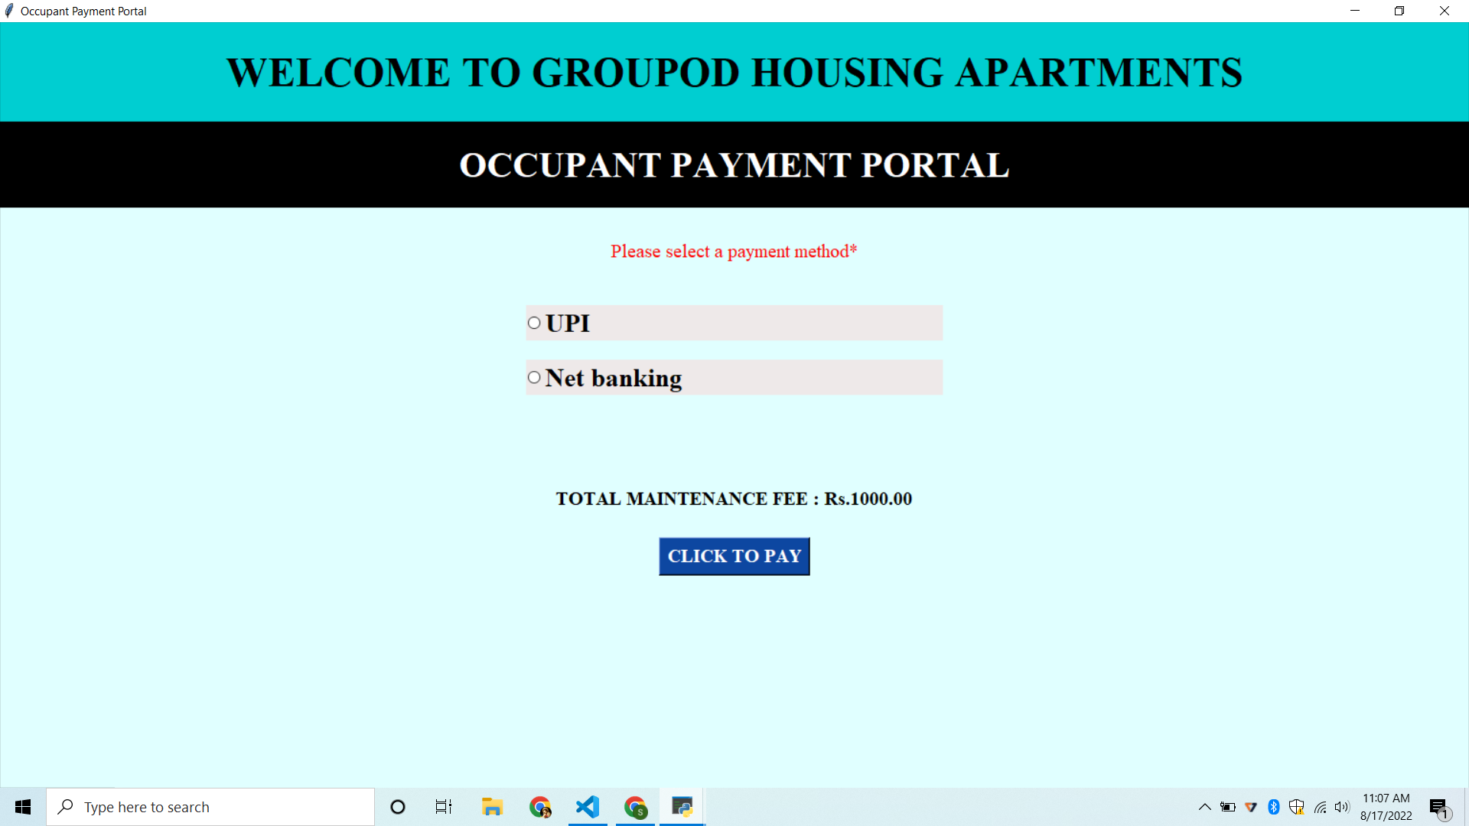

IMPLEMENTATION OF NEW USER MODULE

* The new user will be able to either login and see the flat details or book a house if he already has an account.
* If he doesn’t have the account, he will be able to create a new account
* He can view the details of the flat details, along with BHK type and price of each house depending on the type of BHK
* Thus, the system can generate a block wise list of flat details which will make it easy for the occupant to book a flat.

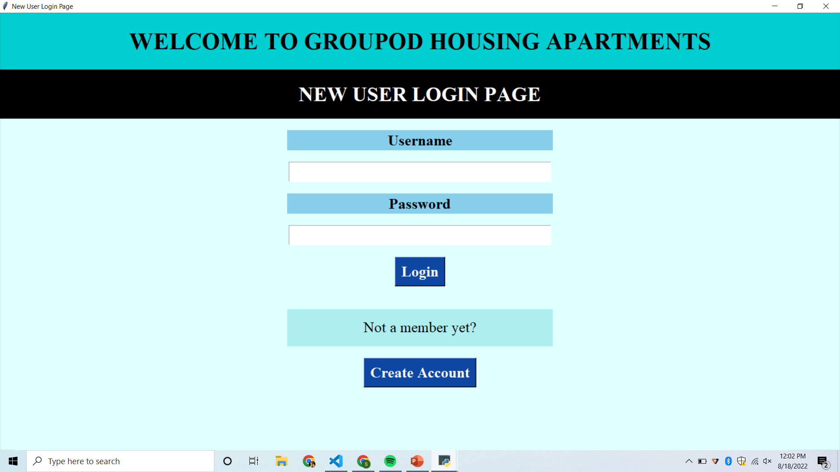

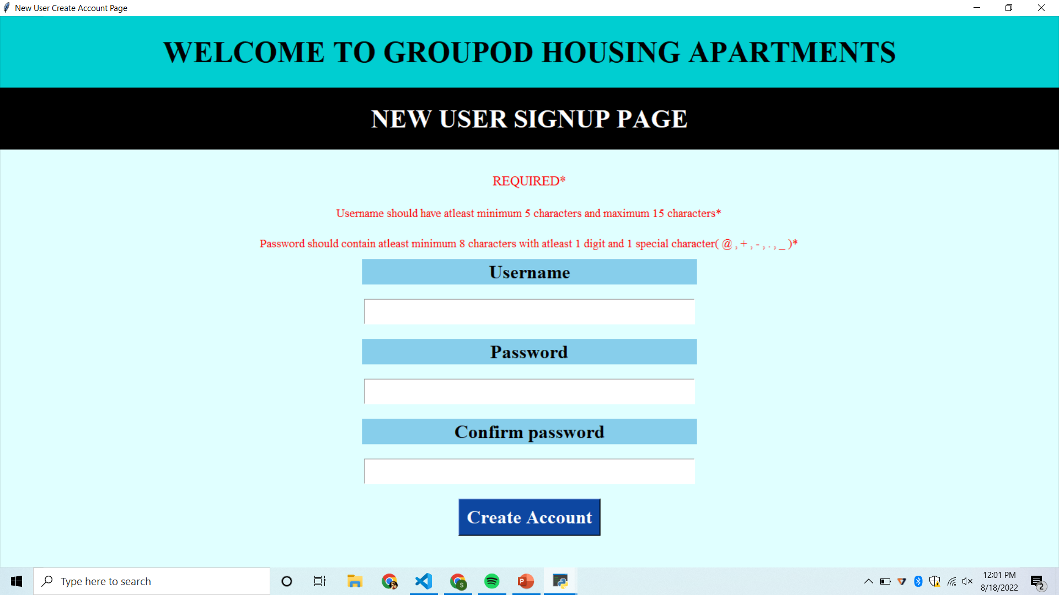

* With Python as a backend and Tkinter as the frontend this module was developed.
* First, we validate the new user’s login and allow the new user to view the flat details in order to book a house

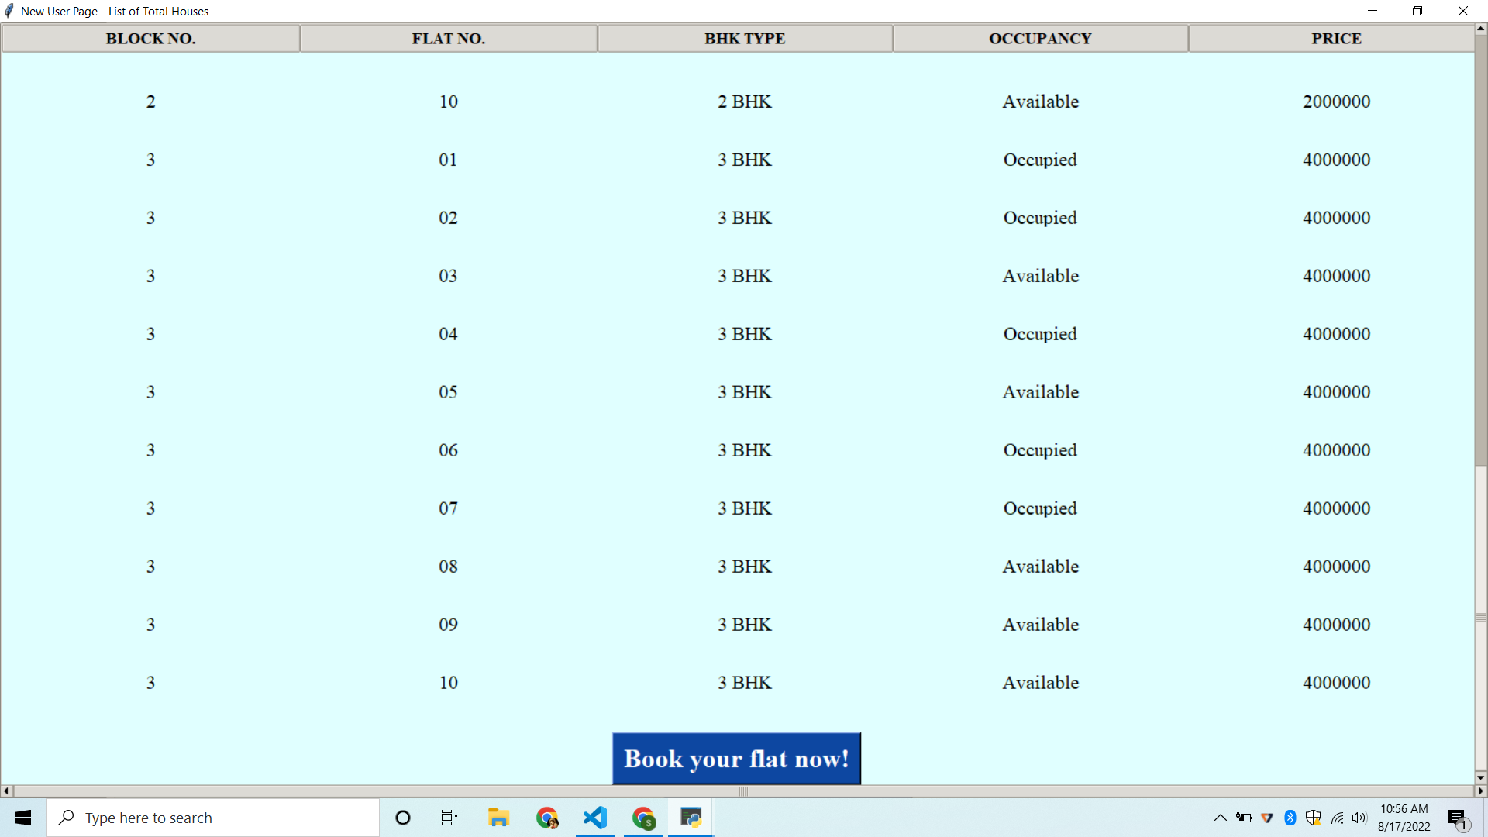

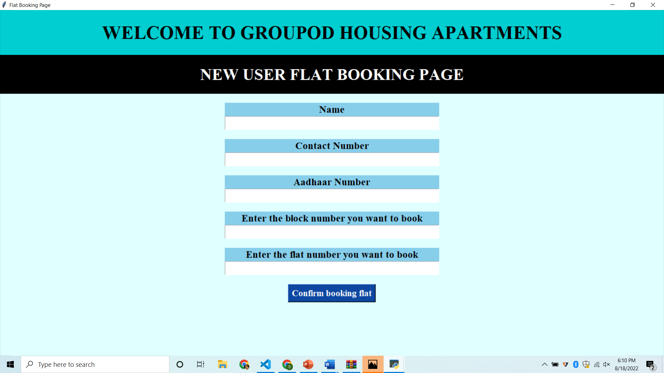

* If he doesn’t have an account, he’ll be asked to create an account based on the rules displayed on the screen
* Then the user will be asked to enter his details like phone number, aadhaar number, name, flat number, block number in order to book a new flat.
* Here we’ve used tkinter’s module named Treeview tkinter to establish a table with all the required content

**DATA STRUCTURES USED**

* 1. **Dictionary**
* A **dictionary data structure** in Python is an unordered collection of items.
* While other data structures use only one value as the element, the dictionary is a slightly more compound data structure which makes of two elements i.e. a pair of elements, namely a key and value.
* The mapping objects are used to map hash table values to arbitrary objects. In python there is a mapping called dictionary, which is the data structure we have used to store details of flat, occupants, etc. in the form of a json file.

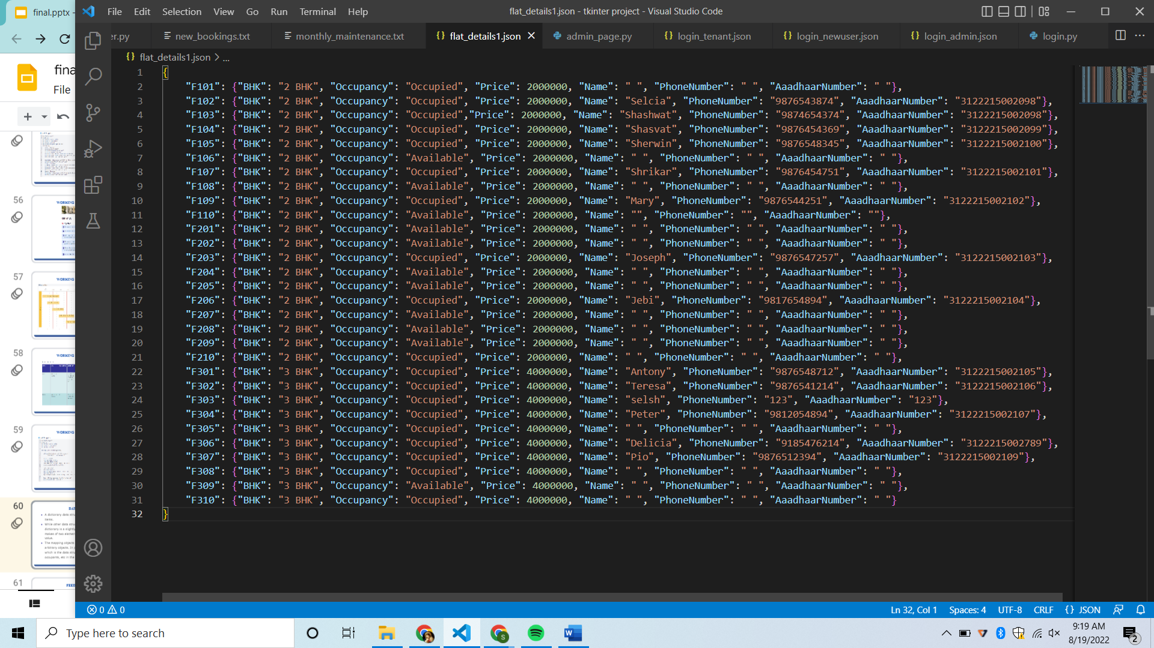

* 1. **Stack**
* A stack is a conceptual structure consisting of a set of homogeneous elements and is based on the principle of last in first out (LIFO).
* It is a commonly used abstract data type with two major operations, namely push and pop.
* We have used stack to implement opening of windows in a easier way of just pressing the “Go back” button



**Client feedback**

* This online house rental solution is fully functional and flexible.
* It is very easy to use.
* This online House rental system helps in back-office administration by streamlining and standardizing the procedures.
* It saves a lot of time, money and labor.
* Eco-friendly: The monitoring of the Housing activity and the overall business becomes easy and includes the least of paper work.
* The software acts as an office that is open 24/7.
* It increases the efficiency of the management at offering quality services to the customers.
* It provides custom features development and support with the software.

**Name of the project –** A system to manage the occupancy of a housing community

**Team members –**

1. S. Selcia – 3122215002098
2. Shashwat Shivam – 3122215002099
3. V. Shasvat Vijay – 3122215002100
4. Sherwin Satya. A – 3122215002101
5. S. Shrikar – 3122215002102

**Client Evaluation Report**

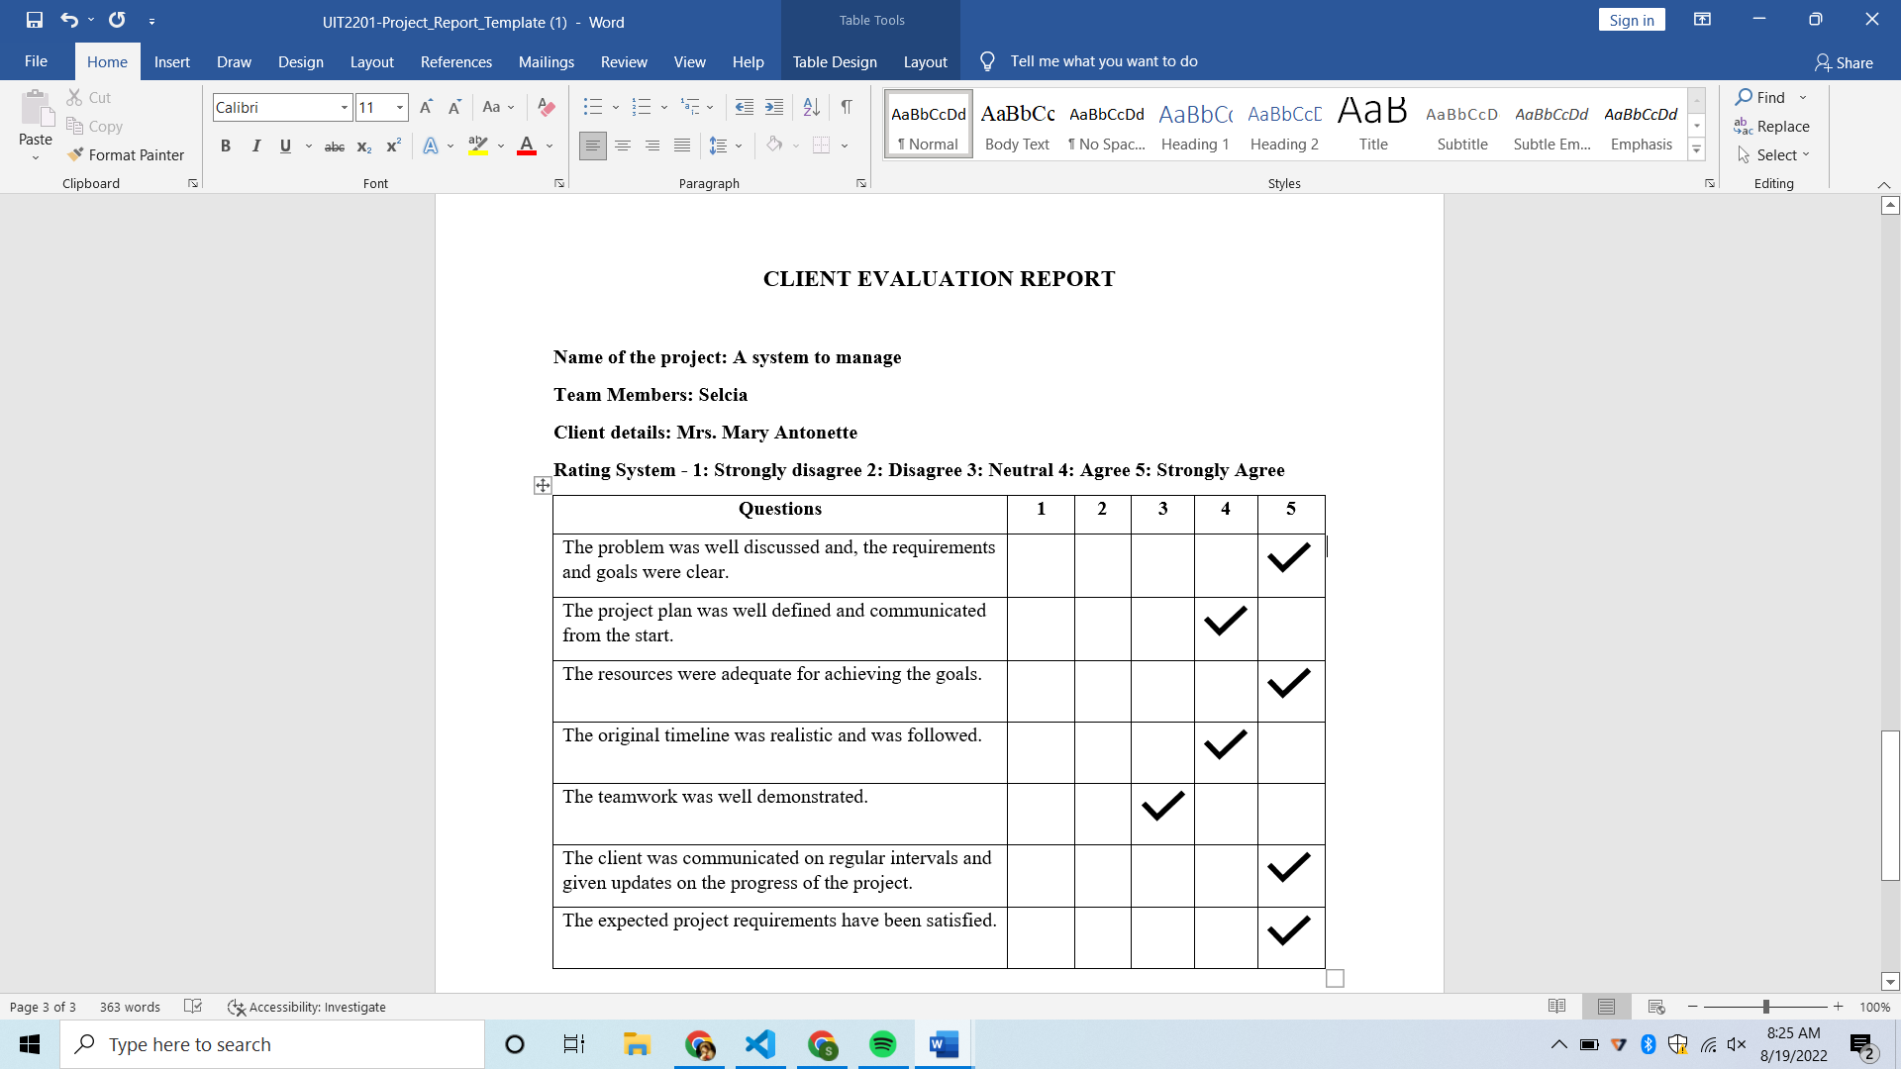

1. **Conclusion and Future Directions**

**Challenges faced**

* All the members in our team were new to creating a team project of this sort.
* Getting used to Jira tool and the Agile methodology and how a scrum team works, documentation, and roles and responsibilities was a challenge.
* Integrating all our slides into a single file was a great challenge because all team members had each work of their own.
* We couldn’t choose the correct GUI for implementing the backend on.
* After deciding our GUI to be Tkinter we needed to know all the commands and functions of the program to integrate the backend in a beautiful way.
* Finally, we didn’t have a particular data structure to implement on our project, with the help of our instructor we chose stack.

**What went right (as per plan)**

* Thanks to our buffer time knowing the vastness of our project and speculating that we would sure make mistakes, we were able to complete all sprints before the given deadline.
* As a team we took care of each other’s backs in all situations, be it high or low.
* We used all the data structures we wanted to implement on the code.
* The use of Json was a very valuable and important part in our project as it helped in storage of data.
* The teamwork was the integral part that went right in our project which led to the eventual completion of the project.

**What went wrong (unplanned)**

* Due to our shortage of time, we were not able to make our GUI look livelier and aesthetic.
* We didn’t calculate the days of us having internal exams which made us late for our planned schedule.
* We couldn’t make the UPI payment and receipt generator due to time constraints in our project.
* We lost a lot of time deciding the suitable GUI for our project.
* We had a little bit of confusion and miscommunication towards the end of the project deadline. (But we got together as a team and completed the work).

**Lessons learnt**

* We learnt how the proper implementation of data structures in real life projects happens in real time.
* Gained an in-depth understanding of data structures such as stacks, dictionaries and the use of Json files to store data.
* Learned about python’s standard GUI library Tkinter and its various advantages and commands.
* Learnt about AGILE methodologies and worked using the Jira tool
* Learned to collaborate and trust each member and grow a bond towards each other.

**What courses should be learnt to make this a better product (releasable in the**

**public domain)**

* Learn App development for executing the program as a mobile app.
* Learn HTML and AWS so that a server can be setup to manage data in a website.
* Design courses used for making an application look lively and colorful can be learnt to impress the clients.
* Learn all the more complex functions of the tkinter and Json.

1. **References**

Here are few sources we accessed for learning :

1. Python Tkinter Tutorial – <https://www.geeksforgeeks.org/python-tkinter-tutorial/>
2. Python - JSON – <https://www.geeksforgeeks.org/python-json/>
3. Python – <https://www.python.org/>
4. Python GUI programming with Tkinter – https://realpython.com/python-gui-tkinter/